**Unit 4**

1. **Explain different types of tools & equipment of sheet metal work along with the sketches. (2014{6.5},2013{2},2012{4},2011{6.5},2010{6})**

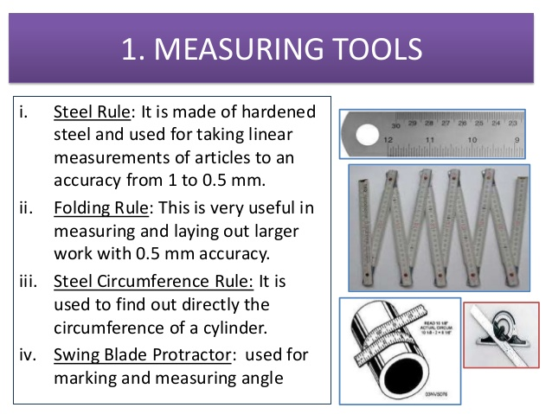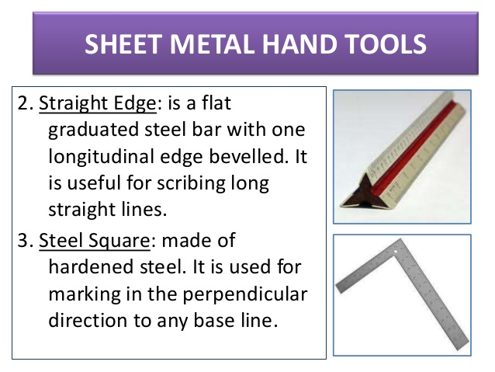

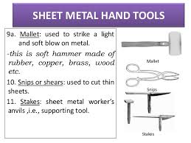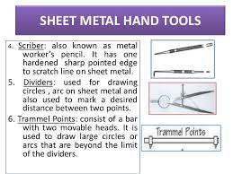

1. **Explain Sketch forming & Spinning with neat sketches. (2015{6.5},2012{8.5},2011{3.5},2010{6.5})**

Stretch Forming-It is a metal forming process where metal is stretched and simultaneously bent to achieve shape change over a die. It is performed on a stretch press where a piece of sheet metal is fitted along its sides. Then sheet is stretched along its sides and this causes the stretch to deform when die applies force on the sheet.

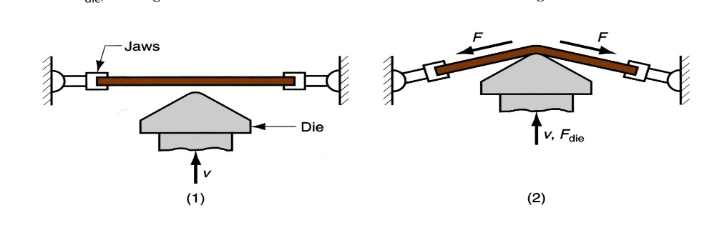

1. start of process; (2) form die is pressed into the work with force *F*die, causing it to be stretched and bent over the form. *F* = stretching force

Spinning- It is metal forming process used to form cylindrical parts by rotating a piece of sheet metal while forces are applied to one side in which an axially symmetric part is gradually shaped over a rotating mandrel using a rounded tool or roller or blank. The blank is the disc-shaped piece of sheet metal that is pre-cut from sheet stock and will be formed into the part.

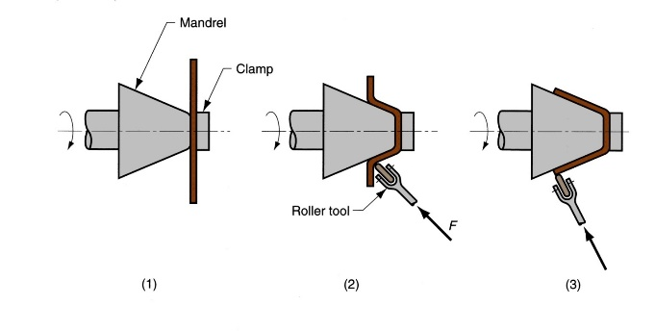

(1) setup at start of process; (2) during spinning; and (3) completion of process

1. **Explain (i) Sintering, (ii) Compacting & (iii) Presintering related to Powder Metallurgy (2015{6.5},2014{6},2013{3})**

Sintering=Process of heating the compacted products in a furnace to below the melting point of at least one of the major constituents under a controlled atmosphere. The sintering temperature and time depend on many factors. In sintering furnace, the metal parts are heated and soaked at the required temperature. During this these powders bond, themselves into bodies and results in strengthening of fragile green compacts produced by the pressing operation. Increases ductility, density, and electrical conductivity of the powder metal parts.

Compacting= Technique of converting loose powder in to compact accurately defined shape and size. This is carried at room temp in a die on press machine. The die consists of a cavity of the shape of the desired part. Metal powder is poured in desired cavity and pressure is applied using punches I top to bottom manner. The pressure applied is uniform throughout top and button and metal is prepared. The final product is not strong and dense and hence sintering is required.

Presintering=These are the processes that are done before the metal is prepared for sintering where various addition of chemicals and products in done to add value in the final product.

1. **Illustrate Nibbling, Coining, Embossing and Notching. (2013{8}, 2012{6},2010{6.5})**

|  |  |
| --- | --- |
| * Notching-Punching the edge of a sheet, forming a notch in the shape of a portion of the punch. |  |
| * Nibbling-Punching a series of small overlapping slits or holes along a path to cut out a larger contoured shape. This eliminates the need for a custom punch and die but will require secondary operations to improve the accuracy and finish of the feature.   [Nibbling](http://www.custompartnet.com/wu/images/sheet-metal/nibbling.png) |  |

Embossing-Used to create indentations in sheet, such as raised (or indented) lettering or strengthening ribs.

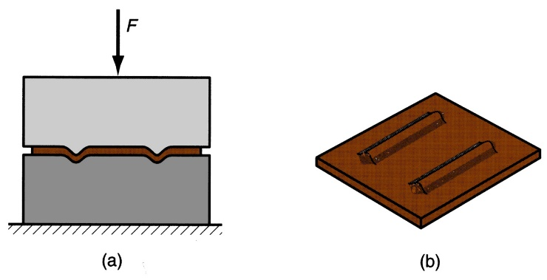

Coining-The only difference is that the flow of metal occurs only at top layers and not at the entire volume. Used to produce coins and consists of punch and die which are engraved with necessary details required on the both sides of the final product.

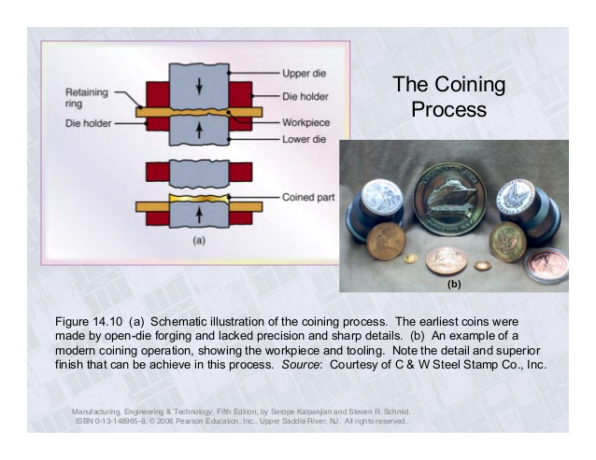

1. **Discuss deep drawing with neat and clean sketches? (2015,2014{6.5},{6.5})**

Deep drawing is one of the most widely used processes in [sheet metal forming](http://www.autoform.com/en/glossary/sheet-metal-forming/). Apart from its use in many other sectors, it is applied in the automotive industry for the manufacturing of car body parts. The deep drawing process is a forming process which occurs under a combination of tensile and compressive conditions. A flat sheet metal blank is formed into a hollow body open on one side or a hollow body is formed into a hollow body with a smaller cross-section.

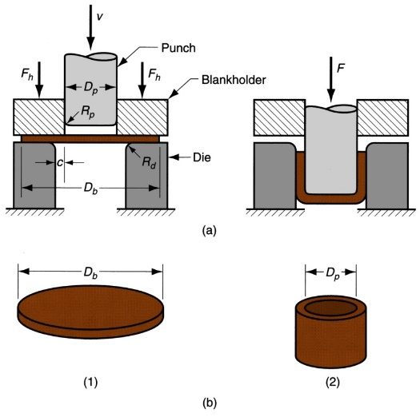

1. **Describe powder usage in metallurgy process (2015{6},2013{5})**

It is method of manufacturing reliable net shaped components by blending elemental or pre-alloyed powders together and compacting them. This blend is known as die and further heat treatment processes are done to this die strong. They include mixing, pressing and sintering. Powder metallurgy takes special characteristics into account such as size, shape and packing which are then converted into high performance shape metals. These powers or processes use automated machines to make the best output possible as it makes high quality complex parts with best tolerances.

1. **Distinguish between primary & secondary process w.r.t powder metallurgy. (2014{6})**

Primary Process-They include processes as blending or mixing, briquetting or compacting, pre-sintering and sintering. Many parts manufactured through powder metallurgy are suitable for using directly. They are not the finishing processes in powder metallurgy.

Secondary Process-They include processes such as sizing, coining, machining, impregnation, infiltration, plating and heat treatment. When better surface finish is required with closed tolerances, secondary processes are used. They are called finishing processes in powder metallurgy.

1. **Explain mechanical pulverization & describe the characteristics of metal powder. (2014{6})**

Mechanical Pulverization-It is the fine crushing of solid material to less than 5mm. Used for the conc. of mineral products in mining and in metallurgy. Methods include crushing, impact and grinding, compressive strain and shearing.

Characteristics-

* Particle shape- Depends on method of powder manufacture. The shape may be modular, irregular angular and dendritic.
* Particle size- Size depends on the control of porosity, compressibility and amount of shrinkage.
* Particle size distribution- The amount of the powder passing through 100, 200 etc mess sieves and influences the packing of powder and its behaviour during moulding and sintering.
* Flow rate- Tis is the ability of powder to flow readily and confirm to mould cavity and determines the rate of production.
* Compressibility-Defined as volume of initial powder to the volume of compact powder and depends upon particle size, distribution and shape.

1. **What are the different applications of shear in blanking & punching? (2013{2.5})**

Cutting processes are those in which a piece of sheet metal is separated by applying a great enough force to cause the material to fail. The most common cutting processes are performed by applying a shearing force, and are therefore sometimes referred to as shearing processes. When a great enough shearing force is applied, the shear stress in the material will exceed the ultimate shear strength and the material will fail and separate at the cut location. This shearing force is applied by two tools, one above and one below the sheet. Whether these tools are a punch and die or upper and lower blades, the tool above the sheet delivers a quick downward blow to the sheet metal that rests over the lower tool. The effects of shearing on the material change as the cut progresses and are visible on the edge of the sheared material. When the punch or blade impacts the sheet, the clearance between the tools allows the sheet to plastically deform and "rollover" the edge. Finally, the shear stress is too great and the material fractures at an angle with a small burr formed at the edge.

[Shearing](http://www.custompartnet.com/wu/sheet-metal-shearing#shearing) - Separating material into two parts

[Blanking](http://www.custompartnet.com/wu/sheet-metal-shearing#blanking) - Removing material to use for parts

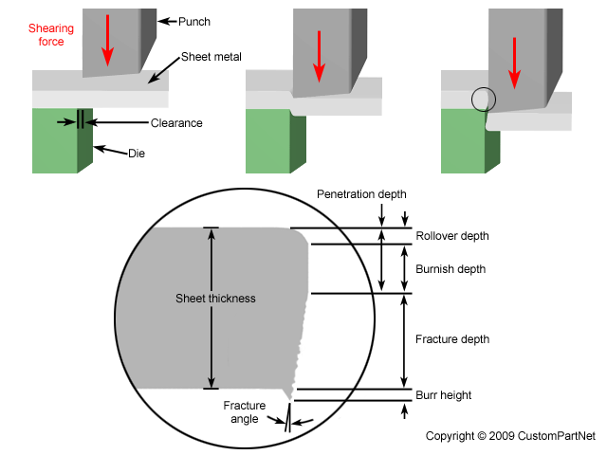

1. **Describe spring back phenomenon. (2013{2.5}, 2013{2.5})**

Spring-back- It is the increase in included angle of bent part relative to included angle of forming tool after tool is removed

* + Reason for spring-back: When bending, pressure is removed, elastic energy remains in bent part, causing it to recover partially toward its original shape. 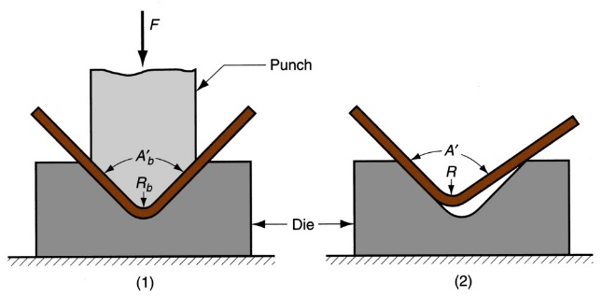

1. **Explain the advantages & disadvantages of powder metallurgy. (2013{5}, 2012{3})**

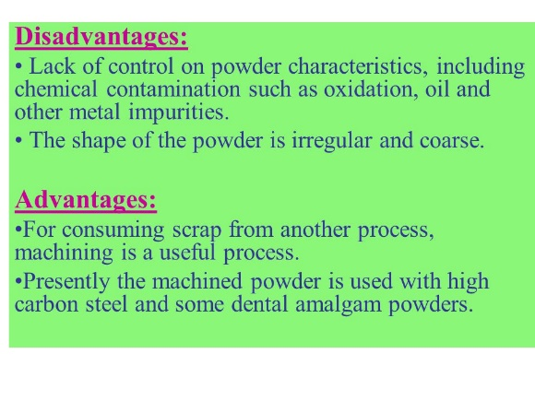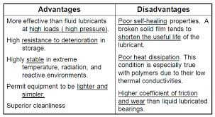

1. **What the different bending operations. (2012{6.5})**

V-shaped bending-This type of ending is done for low production and is performed on a press brake. This mechanism doesn’t need any specific machinery but only a v-shaped press die as v-dies are simple and inexpensive.

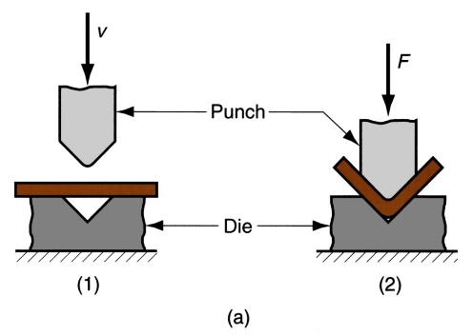

Edge bending- This type of bending is done for high production and is performed on a press brake with a pressure pad. This mechanism requires specific machinery as dies are more complicated and costly. The edges need to be round shaped but not pointed as it might shear the metal.

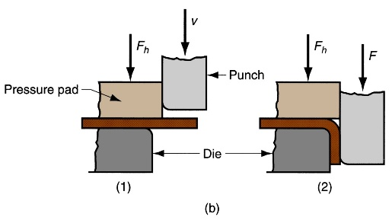

1. **Describe honing & lapping. (2011{4})**

Honing- It is a low-velocity abrading process where material removal is accomplished at lower cutting speeds than in grinding hence heat and pressure are minimized, resulting in excellent size and geometry control. The most common application of honing is on internal cylindrical surfaces. The cutting action is obtained using abrasive sticks mounted on a metal mandrel. Since the work is fixed in such a way as to allow floating, without clamping or chucking, there is no distortion.

Laping-It is a final abrasive finishing operation that produces extreme dimensional accuracy, corrects minor imperfections of shape, refines surface finish and produces close fit between mating surfaces. Most lapping is done with a tooling plate or wheel (the lap) and fine-grained loose abrasive particles suspended in a viscous or liquid vehicle such as soluble oil, mineral oil or grease.

1. **What are GI sheets? What are their purpose? (2010{6})**

Galvanization is the process of applying a protective zinc coating to steel or iron to prevent it from rusting. Galvanized iron (GI) sheets are steel sheets which are basically coated with zinc and include a range of hot dip galvanized and electro-galvanized steel sheets. Zinc weathers at a very slow rate, so the coating generally has a long life. Zinc has a greater electro-negativity than iron and hence provides cathodic (or sacrificial) protection to the steel. This results in the zinc corroding in preference to the steel if the coating is chipped or damaged to expose the base metal. Besides acting as galvanic protector, the other functions of the zinc layer are as follow:

* To retain the steel intact with its full initial strength.
* To provide the surface a more pleasing appearance.
* To increase the life of any suitable organic finishing system applied over it.
* To protect the steel from corrosive attack in most atmospheres, acting as a continuous and lasting shield between steel and the atmosphere.

1. **Explain & draw the sketches of punch & die. (2011{5})**

Punch- It is a metal fabricating process that removes a scrap slug from the metal workpiece each time a punch enters the punching die. This process leaves a hole in the metal workpiece. Its has ability to produce economical holes in both strip and sheet metal during medium or high production processes and the ability to produce holes of varying shapes quickly. The punching process forces a steel punch, made of hardened steel, into and through a workpiece.

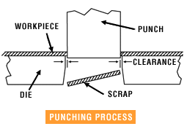

Die-The die may be defined as the female part of a complete tool for producing work in a press. It is also referred to a complete tool consists of a pair of mating members for producing work in a press. Types of dies:

Cutting Dies-These dies are used to cut the metal. They utilize the cutting or shearing action. The common cutting dies are: blanking dies, perforating dies, notching dies, trimming, shaving and nibbling dies.

Forming Dies-These dies change the appearance of the blank without removing any stock. Theses dies include bending, drawing and squeezing dies etc.

**Unit 3**

1. **Explain the advantages & disadvantages of Submerged Arc Welding.**

**(2014{6,6.5),2012{8,5},2011(6,6.5),2010{6,6},2009{6},2013{2.5})**

Submerged Arc Welding is a welding process, which utilizes a bare consumable metallic electrode producing an arc between itself and the work piece within a granular shielding flux applied around the weld. Since the electrode is submerged into the flux, the arc is invisible. The flux is partially melts and forms a slag protecting the weld pool from oxidation and other atmospheric contaminations.

Advantages-

* It has very high welding rate;
* The process is suitable for automation;
* High quality weld structure

Disadvantages-

* Weld may contain slag inclusions
* Limited applications of the process - mostly for welding horizontally located plates.

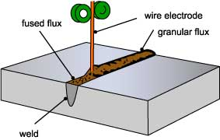

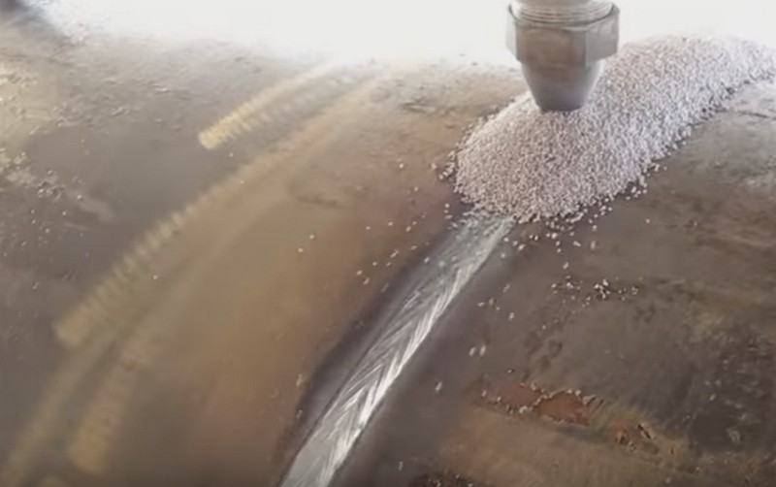

1. **Differentiate between resistance spot, seam and projection welding.**

**(2015{6.5},2014{6},2013{5},2012{7,6.5},2011{6,4},2010{6.5})**

Resistance Spot Welding- In this, no filler rod is required as electrical current is passed through metal under pressure. Distortion and grain growth are minimized. Low skill level is required and easy to automate. It requires low heat input and no weld bead.

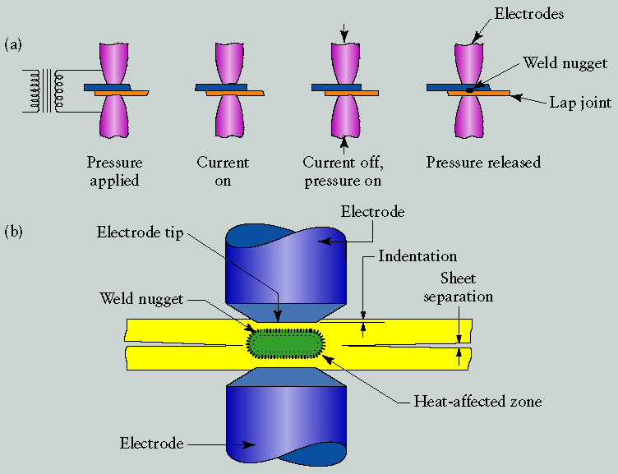

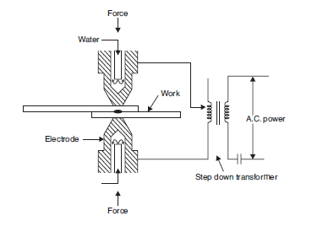

Advantages-

* Low Cost
* Less skilled worker required
* Higher productivity
* Can be easily automated
* No edge preparation is required

Disadvantages-

* The equipment cost is high so it can has an effect on the initial cost.
* Skilled welders or technicians are needed for the maintenance and controlling.
* Some metals need special surface preparation for making the RSW a success.
* The thick jobs are not easy to weld

Advantages-

* Automobiles and aircraft industries
* Utensils and container
* Used for the welding of HSS, Low carbon steel, A, CU, NI & NI alloys

Resistance Seam Welding-Seam welding is like spot welding except that the components to be joined are gripped between revolving, circular copper rollers. The welding current is applied in a series of pulses resulting in a corresponding series of overlapping spot welds being made along the seam.

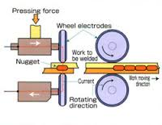

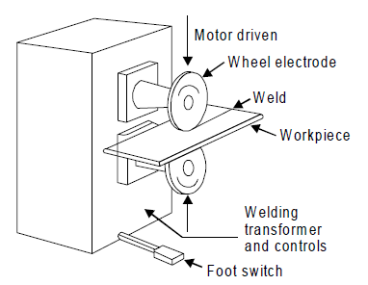

Advantages-

* Produce gas or liquid tight joints.
* Several parallel seams can be produced.
* Overlap can be less than spot welding.

Disadvantages-

* Cost of equipment is high.
* Welding can be done only along straight line.
* Difficult to weld thickness greater than 3mm

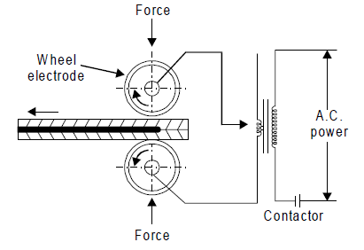

Resistance Projection Welding-In this process the electrodes act as locations for holding the parts to be joined and are, therefore, job-specific. The joint is so designed that projections are preformed on one of the parts to be joined. Projection welding enables the welding pressure and the heated weld zone to be localized at predetermined points. This technique is largely used for small, precision components that need to be accurately located.

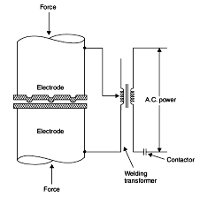

Advantages-

* It is possible to weld more than one spot at a given time.
* Life of electrode is much longer than spot welding electrode.
* The uniformity and appearance of weld is better as compared to spot welding

Disadvantages-

* Making of projections is an extra operation.
* All projection should be of same height.
* Metal which cannot support projection, cannot be weld.

1. **Explain the advantages & disadvantages of Atomic Hydrogen Welding.**

**(2015{6.5},2014{6},2013{5},2012{5})**

Advantages-

* Versatility - readily applied to a variety of applications and a wide choice of electrodes
* Relative simplicity and portability of equipment
* Low cost
* Adaptable to confined spaces and remote locations
* Suitable for out-of-position welding

Disadvantages-

* Not as productive as continuous wire processes
* Likely to be costlier to deposit a given quantity of metal
* Frequent stop/starts to change electrode
* Relatively high metal wastage (electrode stubs)
* Current limits are lower than for continuous or automatic processes (reduces deposition rate)

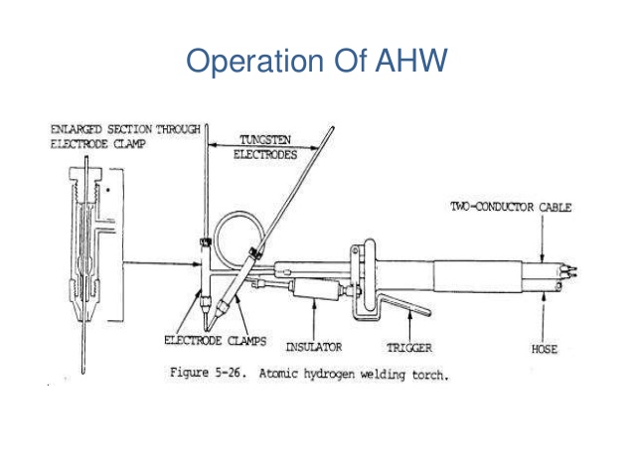

1. **What is Gas Welding (Oxy- Acetylene) and list the equipment used in Gas welding with chemical equations in stages. (2014{6},2011{6},2013{2},2012{2.5})**

Gas welding is called an oxy-fuel gas welding as heat is derives from combustion of acetylene with oxygen. Fuel is generally used is acetylene because of high temperature generated during the process is i.e 31000c.

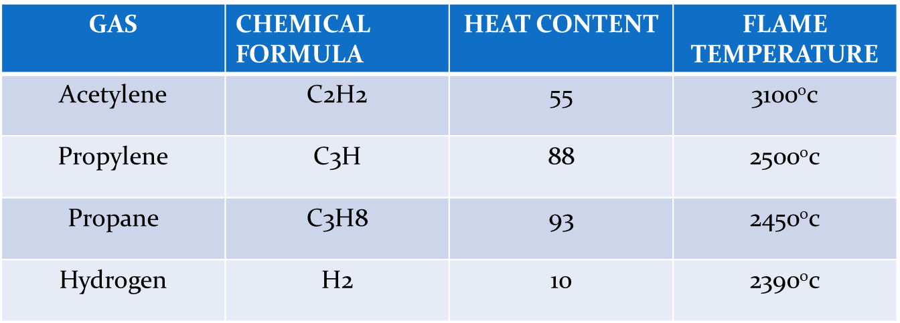

Principle-**When acetylene is mixed with oxygen in correct proportion in the welding torch and ignited, the flame is produced which is sufficiently hot to melt and join the parent metal. A filler rod is generally added to build up the seam for greater strength**. It may be classified as:-

1. *High Pressure oxy-acetylene welding: -* Acetylene is supplied from acetylene cylinder in compressed form

2. *Low pressure oxy-acetylene welding: -* In this acetylene gas is supplied from generator at low pressure. In the generator calcium carbide is added in the chamber in which water is already present. Acetylene starts forming and collected from top of water and used for further welding.

Stage I>> 2C2H2 + 2O2 = 4CO + 2H2

Stage II >> 4CO + 2H2 + 3O2 = 4CO2 + 2H2O

Stage III>> 2C2H2 + 5 O2 = 4CO2 + 2H20 (vapour) + 1284.57 k J / mol

Equipment’s-

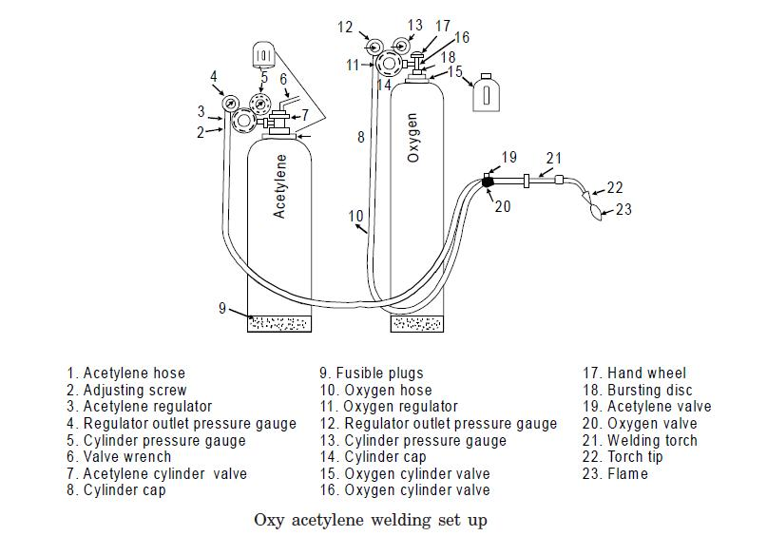

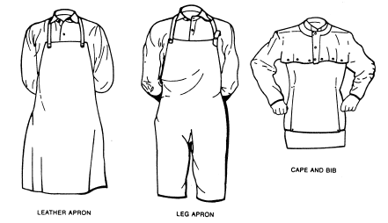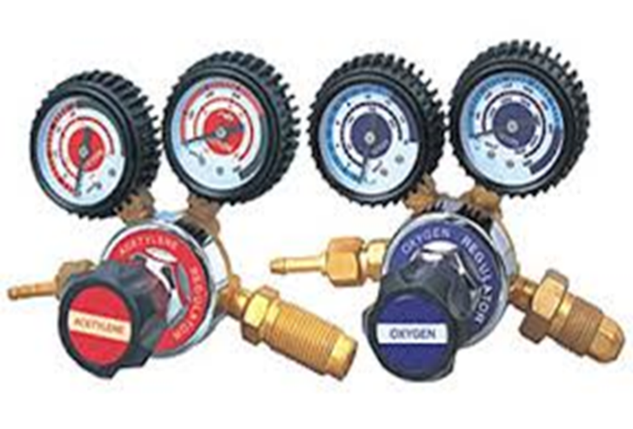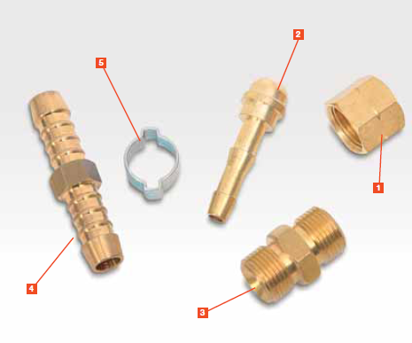

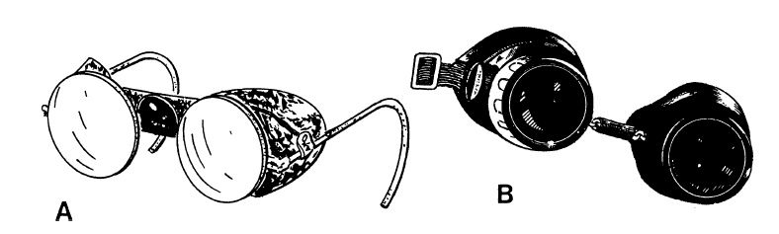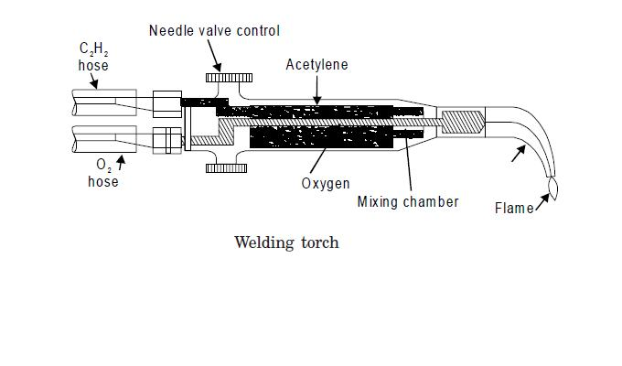

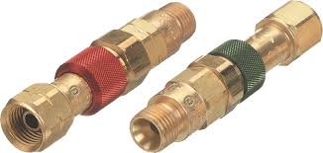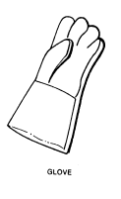

1. **What are different types of flames & mention their temperature range.**

**(2013{5},2012{6},2011{6,6},2009{6.5})**

Neutral Flame- The type of flame where when oxygen to acetylene ratio1.1:1 is called Neutral flame (It has a balance of fuel gas and oxygen) (32000c). Inner core is light blue colour and outer core is of dark blue colour. Flame length is longer. *Used for welding steels, aluminium, copper and cast iron*.



Oxidising Flame-If more oxygen is added, the inner core becomes darker and more pointed, while the envelope becomes shorter and fiercer is called Oxidizing flame. Burns with loud roar. It has the highest temperature about 34000c and used for welding brass and brazing operation.

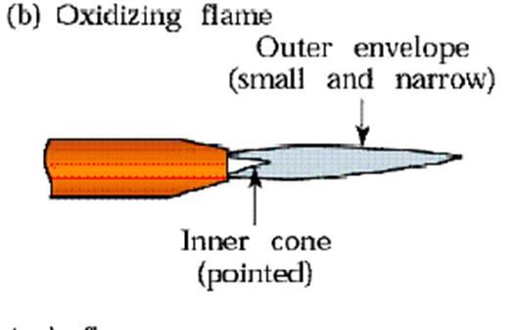

Carbonising Flame-If Oxygen supplied to the neutral flame is reduced, flame immediately changes into a long white inner area (Feather) surrounded by a transparent blue envelope is called Carburizing flame (30000c). Used for steel alloys like for welding high carbon steel.

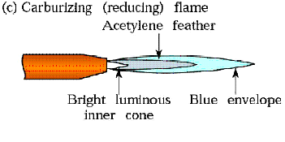

1. **Give the difference between welding, brazing and soldering.**

**(2011{10},2010{6},2009{6.5})**

**Welding-** In welding, the two metals (or thermoplastic) must be similar. For example, copper cannot be welded to steel. Welding uses high temperatures to melt and join two metal parts. A filler metal is often used as well. When properly done, the finished weld is as strong as the surrounding metal. But if the process is not carried out and the welder applies too much heat, it can change the metal’s properties and weaken the weld.

**Brazing-** Brazing joins two metals by heating and melting a filler (alloy) that bonds to the two pieces of metal and joins them. The filler obviously must have a melting temperature below that of the metal pieces. Brazing can join dissimilar metals such as aluminium, silver, copper, gold, and nickel. Flux is often used during brazing. It is a liquid that promotes wetting, which lets the filler flow over the metal parts to be joined. It also cleans the parts of oxides so that the filler bonds more tightly to the metal parts. In addition, fluxes are used in welding to clean the metal surfaces.

**Soldering-** Soldering is a low-temperature analogy to brazing. By the American Welding Society’s definition, soldering takes place with fillers (also known as solders) that melt at below 840°F (450°C). Metals that can be soldered include gold, silver, copper, brass, and iron. The filler, called solder, melts. When it solidifies, it is bonded to the metal parts and joins them. The bond is not as strong as brazed joint or welded one. Solder was once made mainly of lead, but environmental concerns are pushing industry to lead-free alternatives. Soldering is also used to join electrical components. The joint is not necessarily strong or structural, but electrically connects the parts with conductive solder.

1. **Describe the welding defects & joints. (2014{6},2013{2.5},2010{6.5})**

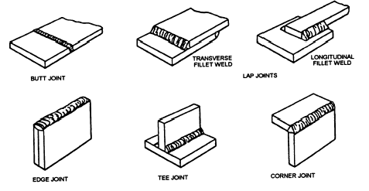

The different types of welding defects are:

1. Lack of Penetration

It is the failure of the filler metal to penetrate the joint. It is due to

(a) Inadequate de-slagging

(b) Incorrect edge penetration

(c) Incorrect welding technique

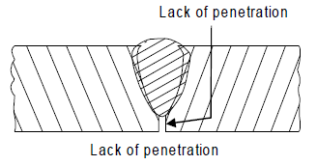

2.Lack of Fusion

Lack of fusion is the failure of the filler metal to fuse with the parent metal. It is duo to

(a) Too fast a travel

(b) Incorrect welding technique

(c) Insufficient heat

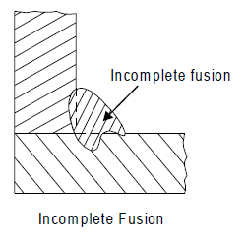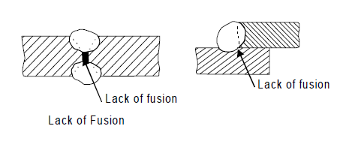

3.Porosity

It is a group of small holes throughout the weld metal. It is caused by the trapping of gas during the welding process, due to

(a) Chemicals in the metal

(b) Dampness

(c) Too rapid cooling of the weld.

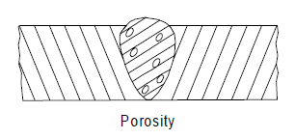

4.Slag Inclusion

It is the entrapment of slag or other impurities in the weld. It is caused by

(a) Slag from previous runs not being cleaned away,

(b) Insufficient cleaning and preparation of the base metal before welding commences.

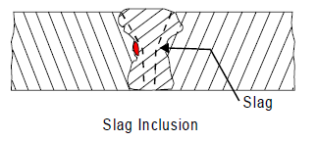

5.Undercuts

These are grooves or slots along the edges of the weld caused by

(a) Too fast a travel

(b) Bad welding technique

(c) Too great a heat build-up.

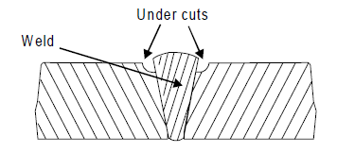

6.Cracking

It is the formation of cracks either in the weld metal or in the parent metal. It is due to

(*a) Unsuitable parent metals used in the weld*

(*b) Bad welding technique*

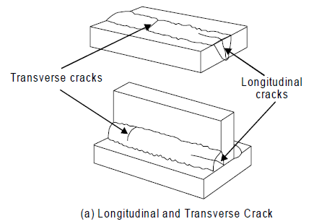

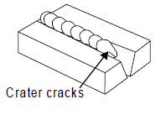

7.Distortion

Distortion is due to high cooling rate, small diameter electrode, poor clamping and slow arc

travel speed

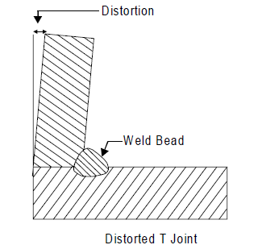

1. **Differentiate between TIG (Tungsten Inert Gas) and MIG (Metal Inert Gas) welding.**

**(2012{5},2010{6},2014{2})**

TIG- It is a welding where the electrode is tungsten which is not consumed. The filler rod is separate and fed manually. It requires high skill level required to achieve good weld. It is difficult to automate but low heat input is given and small weld bead is produced. Distortion and grain growth are minimized.

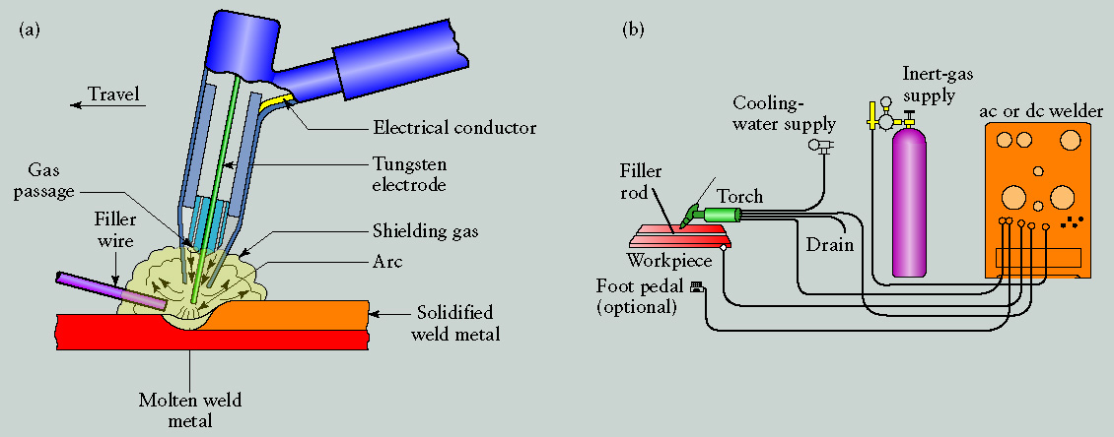

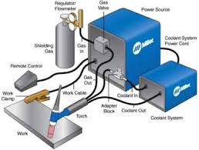

Advantages-

* Weld composition is close to that of the parent metal;
* High quality weld structure
* Slag removal is not required (no slag)
* Thermal distortions of work pieces are minimal due to
* concentration of heat in small zone.

Disadvantages-

* Low welding rate
* Relatively expensive;
* Requires high level of operating skill.

MIG- It is welding where complex mechanism is involved but is simple to perform and easy to automate. The electrode is also the filler rod which is fed continuously from a spool. It melts in the arc. Low skill level can achieve good weld and there is medium heat input whereas distortion and grain growth are significant. Used for steel or aluminium.

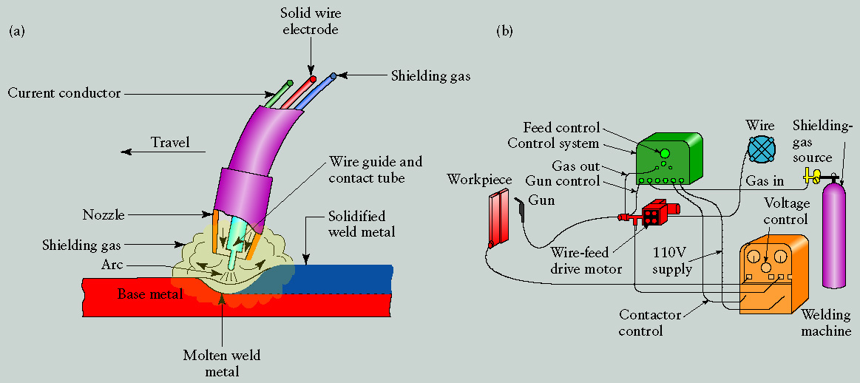

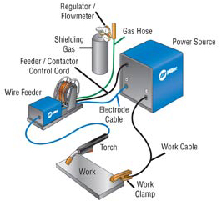

Advantages-

* Continuous weld may be produced (no interruptions)
* High level of operator’s skill is not required
* Slag removal is not required (no slag)

Disadvantages-

* Expensive and non-portable equipment is required;
* Outdoor application is limited because of effect of wind, dispersing the shielding gas.

1. **Describe Flux along with its properties. (2014{6},2010{4},2009{3})**

* Gas forming- Isolating welding zone from ambient air. e.g organic matter like wood pulp
* Slag forming- china clay, felspar, manganese, & titanium ores
* Reducing- ferro silicon,ferro titanium,ferro manganese reduces oxides
* Stabilizing- Ionized the zone b/w electrode and part to be weld and ensuring stable burning.
* Binding- so that covering should have proper binding with bare electrode

1. **What are the advantages & disadvantages of Carbon Arc Welding? (2015{6},2014{6.5})**

A process in which heat is generated by an electric arc struck between a carbon electrode and the work piece. The arc heats and melts the work pieces’ edges, forming a joint. If required, filler rod may be used in Carbon Arc Welding. End of the rod is held in the arc zone. The molten rod material is supplied to the weld pool.

Advantages-

* Low cost of equipment and welding operation;
* High level of operator skill is not required;
* The process is easily automated;
* Low distortion of work piece

Disadvantages-

* Unstable quality of the weld (porosity);
* Carbon of electrode contaminates weld material with carbides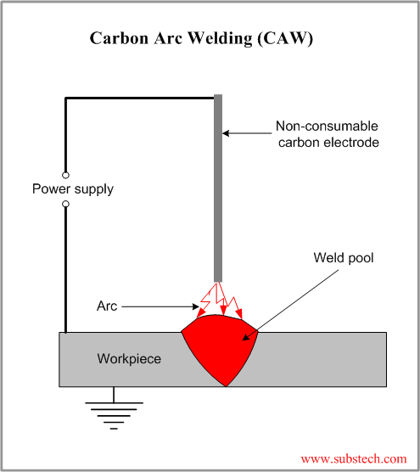

1. **Explain edge preparation. (2014{2},2013{2.5})**

It is done to ensure the complete penetration and sound weld and edge preparation is essential.

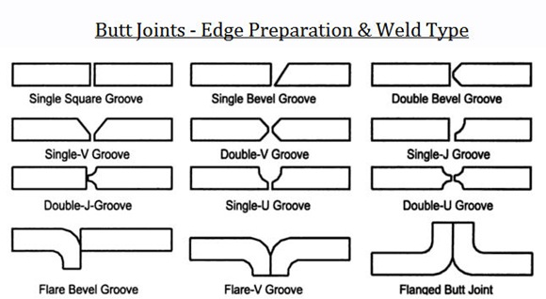



1. **Explain Flash Butt welding. (2013{5})**

The two ends of the rods are brought together with just sufficient force to ensure the current can flow without arcing. The resistance of the joint interface ensures that local heating will take place on the passage of a heavy electric current at low voltage. When the metal in the joint zone has reached its welding temperature, the current is switched off and the axial force on the joint is increased to complete the weld. Flash butt welding is like upset butt welding except that the heat required for melting is obtained by means of an arc rather than the simple resistance welding.

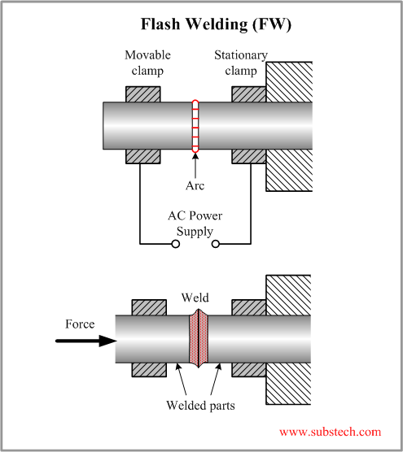

Advantages-

* It consumes less welding current
* The process is cheap.
* The process is fast.
* It offers 100% strength factor.
* The preparation of weld surface is not required

1. **Differentiate between AC & DC welding. (2010{4},2012{2.5})**

Alternating Current (from Transformer)-

* More efficiency
* Power consumption less
* Cost of equipment is less
* Higher voltage – hence not safe
* Not suitable for welding non-ferrous metals
* Not preferred for welding thin sections
* Any terminal can be connected to the work or electrode

Direct Current (from generator)-

* Less efficiency
* Power consumption more
* Cost of equipment is more
* Low voltage – safer operation
* suitable for both ferrous nonferrous metals
* preferred for welding thin sections
* Positive terminal connected to the work
* Negative terminal connected to the electrode

1. **Explain different types of electrode. (2014{2},2011{6.5})**

Filler rods are used in arc welding are called electrodes. Metallic wires having same composition as the metal to be weld. Coated uniformly with a protective coating called flux. Eg. titanium oxide, potassium oxide, cellulose, iron or manganese, Ferro silicates, carbonates, gums, clays, asbestos etc.

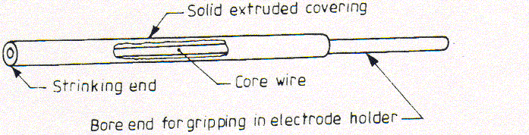

Types of Electrode

* **Consumable-** Electrode that is consumed during welding. E.g. MIG, Submerged Arc Welding etc.
* **Non-consumable-**D.C (Carbon, graphite) & A.C (Tungsten). These electrodes are bare electrodes. Used in carbon arc & TIG welding
* **Bare Electrode-** It is not coated with flux**.** Used in carbon arc & TIG welding
* **Coated Electrodes (Stick Electrode)-** It is coated with flux. Used in shielded Metal Arc

1. **Define the term polarity and explain its types. (2011{2},2010{4})**

When the machine is set for straight polarity, the current flows from the electrode to the weld surface and creates considerable heat in the metal. When the machine is in reverse polarity, the current is backwards and is flowing from the metal to the electrode causing a greater concentration of heat at the electrode.  In an opposed weld, there are three material interfaces: two electrode-to-part interfaces and one part-to-part interface. To take advantage of polarity, the negative electrode should be placed on the most resistive part and the positive electrode against the most conductive part. This will increase the heat at the interface of the two materials and reduce the heat at the electrode–to-part interfaces. Reversing the polarity will cause the material interface to be colder and may cause electrode sticking.

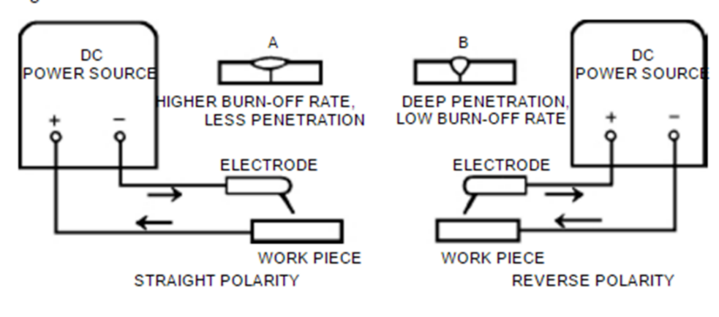

1. **Why is electrode coated? (2011{2}, 2013{2.5})**

Stabilization of the Arc - A stabilized arc is one that starts easily, burns smoothly even at low temperatures, and can be maintained using either a long or a short arclength.

Alloying Additions to Weld Metal - A variety of elements such as chromium, nickel, molybdenum, vanadium and copper can be added to the weld metal by including theming the coating composition. It is often necessary to add alloys to the coating to balance the expected loss of alloys of the core wire during the welding operation.

1. **How can you differentiate between Oxygen and Acetylene cylinders? (2011{2},2013{2.5})**

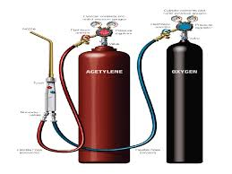

The Oxygen cylinder is of black or blue colour whereas Acetylene cylinder is of red or maroon colour. Pressure

Oxygen – 125 kg/cm2

Acetylene – 16 kg/cm2

1. **What is welding and classify it? (2012{2.5})**

Welding is a material joining process which produces joint of materials by heating them to suitable temperatures with or without the application of pressure and with or without the use of filler material. Welding is used for making permanent joints. It is used in the manufacture of automobile bodies, aircraft frames, railway wagons, machine frames, structural works, tanks, furniture, boilers, general repair work and ship building.

Classification-

(i). *Arc welding*

Carbon arc

Metal arc

Metal inert gas

Tungsten inert gas

Plasma arc

Submerged arc

Electro-slag

Atomic Hydrogen

(ii). *Gas Welding*

Oxy-acetylene

Air-acetylene

Oxy-hydrogen

(iii). *Resistance Welding*

Butt

Spot

Seam

Projection

Percussion

(iv)*Thermite Welding*

(v)*Solid State Welding* Friction Ultrasonic Diffusion Explosive Forge

(vi)*Newer Welding* Electron-beam Laser

(vii)*Related Process* Oxy-acetylene cutting Arc cutting Hard facing Brazing & Soldering

**Unit 2**

1. **Describe the tools used in fitting shop. (2014{4},2010{6,6},2009{6})**

*DIE AND DIE STOCK*

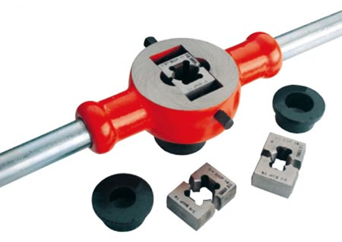

Die and die stock are used for cutting external threads. Dies are made from tool steel and have internal threads. Before starting the operation, the job is held firmly in a vice or by any other job holding devices. The proper die is selected for the desired threading and then starting point of the job is chamfered so that the die is properly adjusted on the job. By holding the die into die stock, the handle is rotated by hand.

*TAPS*

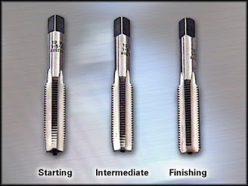

Taps are used for making internal threads. It is inserted into the face of the hole at right angle. In hand tapping three taps are commonly used. Tap have toothed body with a cylindrical shape. It also consists of a flute and the taps are available in a set of three taps namely Taper, intermediate and plug Taps and during tapping it is used in the same order. The tap is hold by the tap holder and before tapping hole must be drilled to the size of the root diameter of the thread. Before tapping tap must be held at right angle to the plane of the work piece. Remember if 1st tap is rotated clockwise two rounds, then also rotate one round of same tap anticlockwise.

*STRIKING TOOLS*

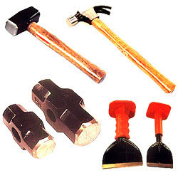

Hammer is the only tool generally used for striking in fitting shop. These are used for chipping, fitting, punching etc. A hammer consists of a heavy iron body with wooden handle. The weight ranges from 0.25 to 2 kg. The classification of hammer is done based on the shape of the peens. If the shape of the peen is ball or spherical then it is called as Ball peen. If the peen is parallel to the handle of the hammer, then it is Straight peen hammer. If the peen is across the handle of the hammer, then it is Cross peen hammer. If the shape of the peen is same as face, then it is Double ended hammer.

*CHISELS*

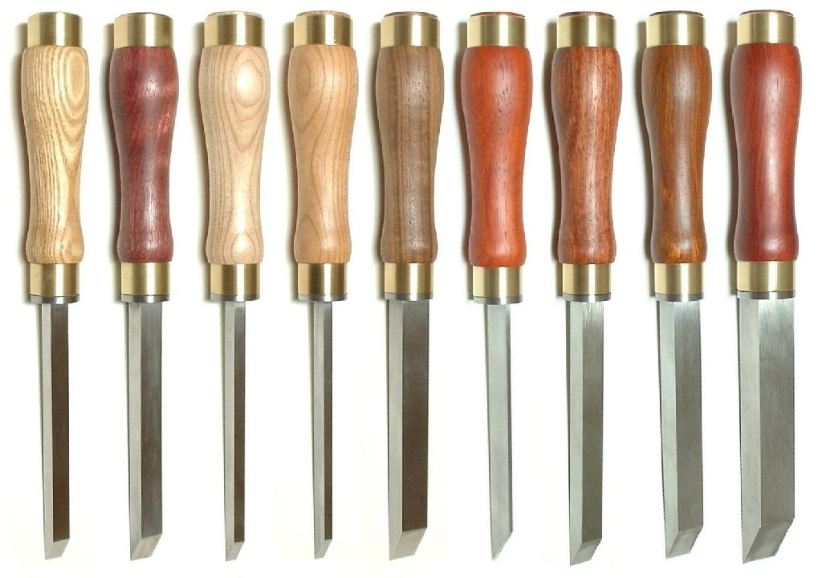

These are used for chipping away the material from the work piece. These are made up of high carbon steel generally 6” to 8” long. The top is flattened and a sharp cutting edge is made on the bottom side. Chisels are classified based on shapes and width of the cutting edge. Commonly used forms of chisels are flat, cross cut, half round and diamond point chisel.

*HACKSAW*

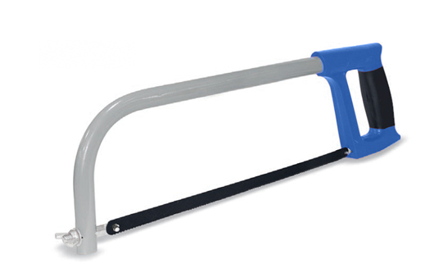

It is used for cutting of rods, flats etc. The blade of the hacksaw is made up of high carbon steel or speed steel. And the frame is made from mild steel. The blade is placed inside the frame and is tightened with the help of flange nut. The teeth of saw blades are generally forward cut. The hacksaw should be used in straight direction otherwise it will result in breaking of the blade. The length of blade varies from 8” to 14”, but generally 12” blade is used in fixed frame hacksaw.

*CALIPERS*

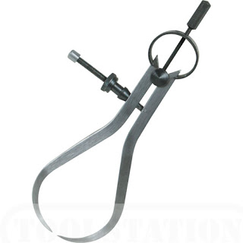

It is generally used to measure the inside or outside diameters. It is made in different sizes and shapes. It consists of two bent legs connected at one end by means of rivets or bolts. The edges are made to just touch the job, then the dimension is measured with the help of steel rules. Types are:  
*1. Outside calliper*  
*2. Inside calliper*  
*3. Spring calliper*  
*4. Jenny calliper or odd leg calliper*

*DIVIDERS*

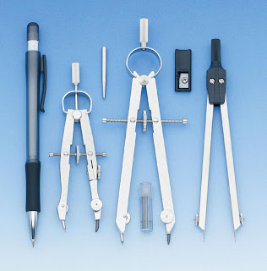

These are made of steel. Dividers have two legs having sharp feet. These are hinged at the top. It is used for marking arcs, dividing a line or transferring the dimension.

*VERNIER CALIPER*



It is a precision instrument used for measuring lengths and diameters. It can be used for measuring internal and external dimensions. It consists of a graduated bar of rectangular section. It has two jaws, one is movable with a small Vernier head and other is fixed. A fine adjustment nut is also attached to the head. The dimension is measured by the jaws and is indicated on graduated bar. Minimum dimension that can be expressed on Vernier calliper is known as least count. The least count of Vernier is 0.001” or 0.02mm. Generally, the material of all parts is stainless steel.

*STEEL RULES*

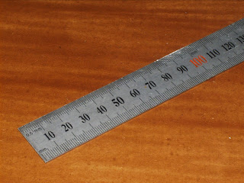

These are made up of stainless steel and are available in many sizes ranging from ½ to 2 ft. These are marked in inches and millimetres. The edges of steel rules should be protected from rough handling.

*SURFACE PLATE*

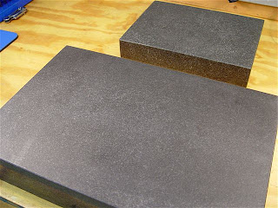

It is used for testing the flatness, trueness of the surface. It is made up of cast iron or graphite. Its upper face is flat to form a very smooth surface. It is covered with a wooden cover while not in use. It is used to test a try square and this plate is used as a base for V-block, sine bar etc. and other measuring instruments during measurement.

**CENTER PUNCH**

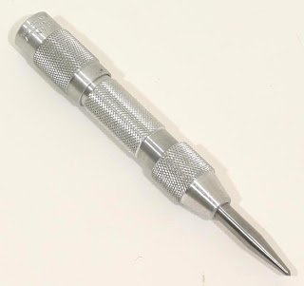

It is like a dot punch except the angle of the punching end is 900. It is used to mark the centre of the hole before drilling.

**TRY SQUARE**

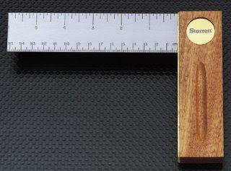

It is used for checking sureness of two surfaces. It consists of a blade made up of steel which is attached to a base at 900. The base is made up of cast iron or steel. Try square is also used for marking right angles and measuring straightness of surfaces. It is an instrument used to draw straight lines at right angles to a true surface.

**BENCH VICE**

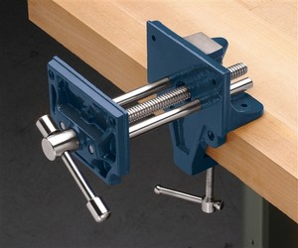

It is a common tool used for holding jobs. It consists of cast iron body and cast iron jaws. Two jaw plates are fitted on both the jaws. Jaw plates are made up of high carbon steel and are wear resistant. One jaw is fixed to the body and the second slides on the square threaded screw with the help of a handle. The jaws are opened to required length, job is placed in the two jaws and is fully tightened with handle. It is fixed at the four corners of the fitter’s working bench, and it is up to the waist height.

1. **What are forging tools & its defects. (2014{5},2011{6},2009{6.5},2010{6})**

**Black Smith’s Forge**

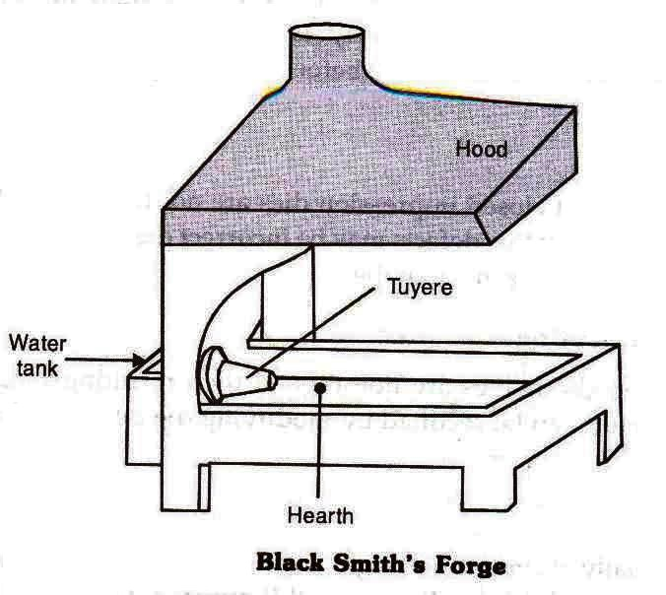

It is a kind of furnace used by blacksmiths for heating metal jobs while forging. Its main parts consist of:

**Hood:** Which forms the outer cover of the furnace,

**Chimney:** For discharging the fumes and smokes generated,

**Tuyere:** From where the fire blast is injected,

**Blast Producer:** Which produces the required air thrust for creating the fire blasts (usually fired by motors) and also a few auxiliary parts like Rake: which removes slag, Slice: For collecting coal over the fire, Poker: For poking and optimizing fire strengths.

**Anvil**

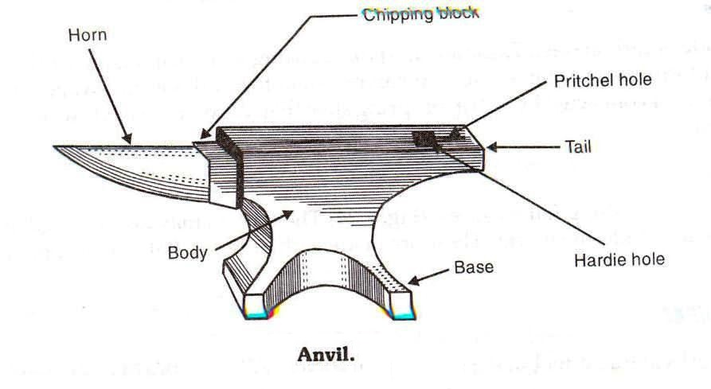

A blacksmith uses this tool to support the job which is being hammered by him, probably during the process of hand forging. The body of an anvil is made up of mild steel and the top surface which needs to be tough and rugged is made up of a high carbon steel welded section. The protruding “beak" shaped portion becomes useful for operations that involve bending. The anvil also incorporates a square cross-sectional hole for accommodating shanks of other different tools.

**Swage Block**

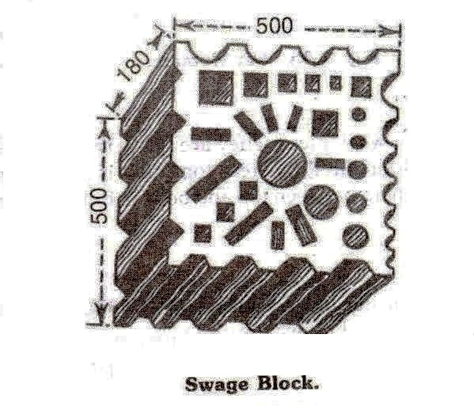

These are square blocks made of cast iron and may consists a multiple range of slots of different size and shapes over one of its square surfaces suiting all types of swaging work. The sides have channelled grooves also favouring swage operations. Usually a swage block is fitted at a preferable height over a stand while doing the operations.

**Sledges, Fullers, Swages**

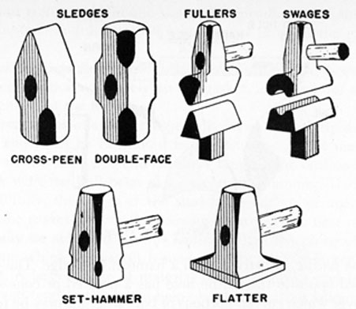

**Fuller**: These are often used at the beginning of a nicking down process of a metal and the reduction process. A fuller is held at the point of the metal which is to be reduced over a hardie by the smith and wielded by the striker. Fullers come with different edge sizes depending upon the need of the blacksmith’s operations.

**Sledges:** Primarily a blacksmith may prefer two types of hammers for the operations of hand forging, the smith’s hand hammer and the sledge hammer. The first kind of hammer is used by the smith for directing the hammering area, while the sledge hammer is used by his assistant or the striker for wielding the job work.

**Flatters**: These are small iron tools having a square flat surface bottom (3 in. square) specifically designed for providing flat finishes to a metal job.

**Punches & Drift**

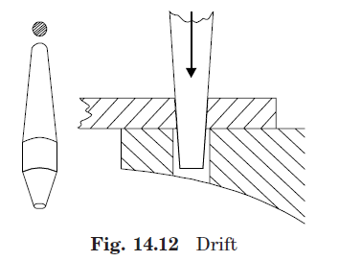

Punches are made up of high carbon steel and are used for making rough holes in hot metal pieces. Punches are available in different sizes but have a common shape. A drift is a large sized punch used to enlarge a hole.

**Hardie**

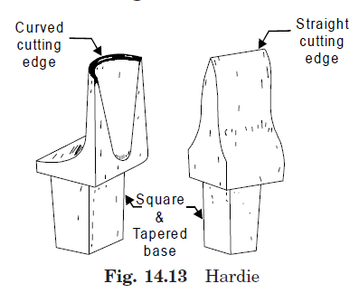

**Chisels**

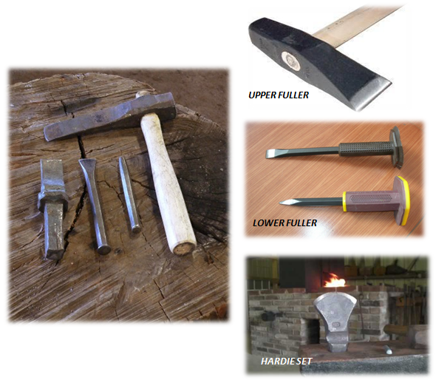

Chisels are used for cutting metal pieces in hot and cold state. Chisels are divided into following categories: 1) *Hot chisel 2) Cold chisel 3) Hardie set .*Hot chisel is used to cut the metal in hot state and cold chisel to cut the material in cold state. Main difference between these chisels is the cutting angle. In hot chisel cutting angle is 30 degrees and in case of cold chisel 60 degree. A hardie set consists of three parts:

1) *Shank 2) Body 3) Cutting edge. The* shank is fitted into the hardie hole in the anvil. Chisels and the hardie set are made from carbon sheets. It is hardened upto the desired level with proper tempering.

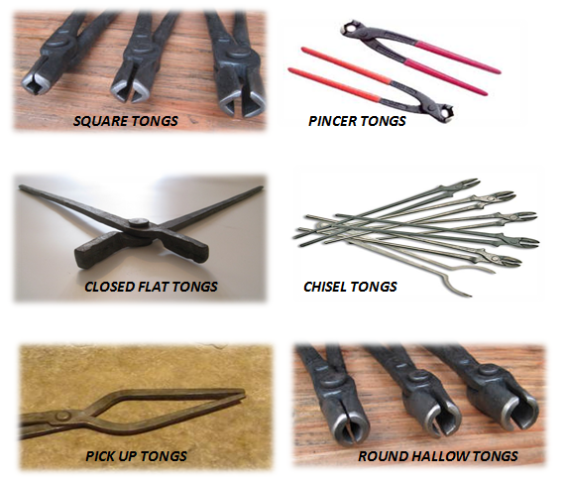

Tongs are used for holding and turning hot metal pieces. Depending upon their use, tongs are classified into many types. All types of tongs have similar construction except the mouth. A tong has two legs riveted from a suitable place. These are made up of mild steel. It is made in two pieces and both the pieces are joined by hinges. The length of the tongs varies from 12” to 18”. It is classified based on the shape of the mouth of the tongs.

1. **Describe all smithy processes. (2013{5},2012{8},2011{6},2010{6})**

**Fullering**

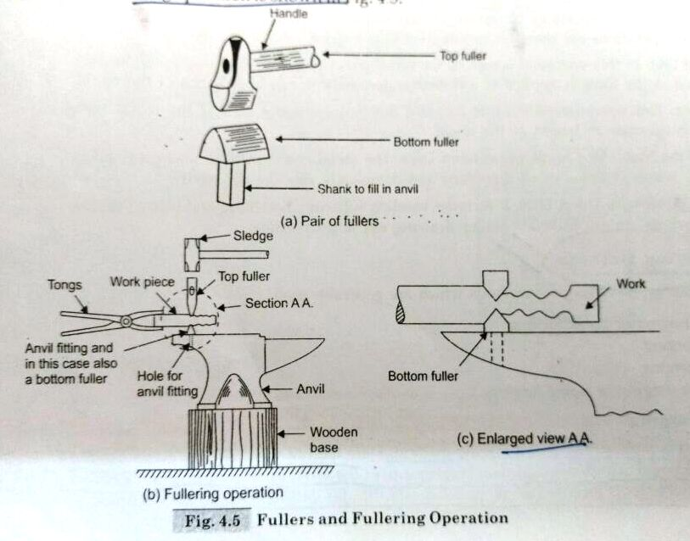

Fullering process is done on an anvil. Lower part of fuller set is kept in the hole of the anvil. Hot work piece is placed in the groove of the lower fuller. Upper fuller is placed on the job and hammering is done on the upper portion. Fullering is done for drawing and grooving.

**Flattening**

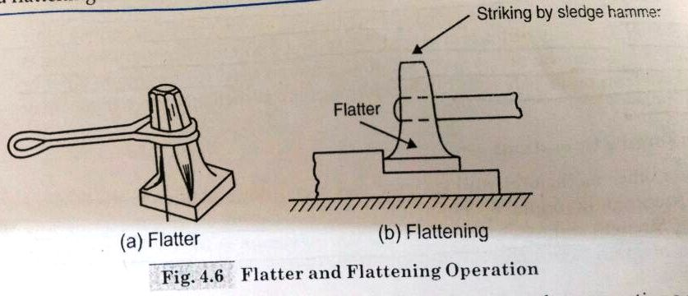

The flattening is carried out after drawing out, fullering or any other operation to remove the fullering marks for leveling and finishing flat surfaces. It is used to reduce the thickness of the job to required shape.

**Swaging**

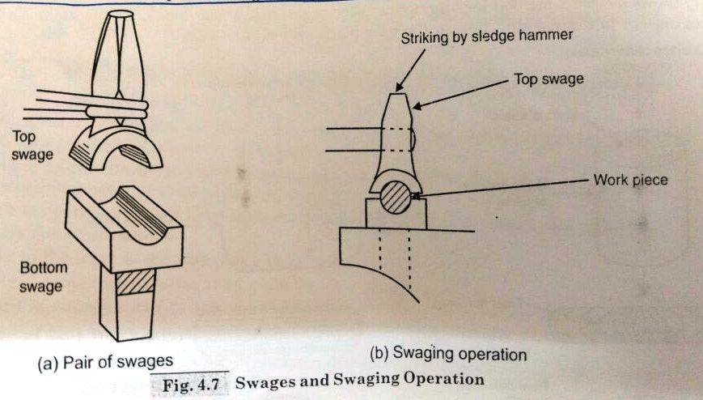

Swaging is a process used to form or finish different shapes such as circular, hexagonal and square etc. The hot piece is held between the upper and lower part of the swages. With the help of a hammer blows are given to the upper part of the swage.

**Punching**

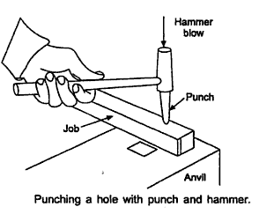

Punching is the process in which a rough hole is made into the hot work piece. The job is heated to a desired temperature and then it is placed on the anvil. Punch is placed on the hot metal piece. With the help of sledge hammer, the punch is forced to pierce the metal upto half of the metal thickness. Then the punching is done from the second side by inverting the work piece. A rough hole is produced.

**Bending**

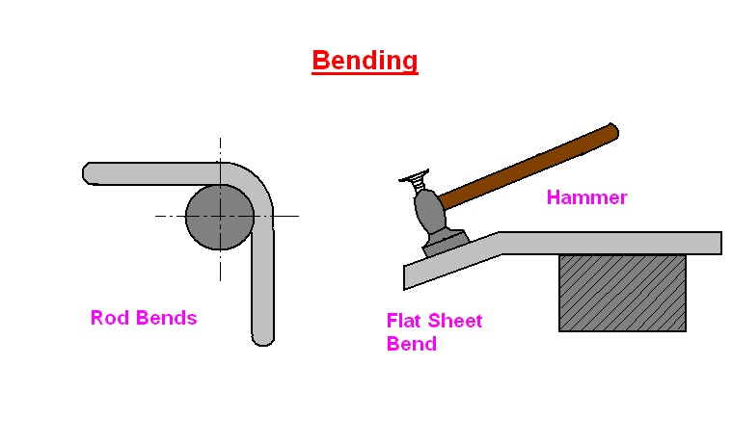

The process of giving desired angles or curvature to hot piece is known as bending. The process is done on the edge of the anvil or on chipping block. Circular shapes, eye bolts hooks or any other type of bent shape can be prepared with this operation. The hammering is done on hot work piece with a hand hammer. Hot work piece is held in a tong.

**Drifting**

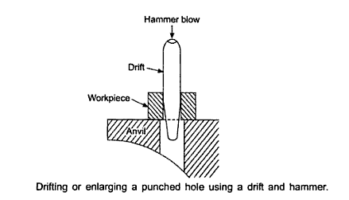

It is a process of finishing and enlarging the hole. The process is similar to punching. To continue punching without using a die is called to be as drifting but in this case a tool known as drift is used.

**Upsetting**

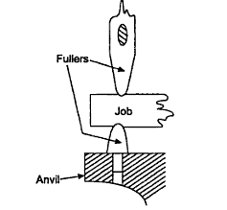

It is the process in which the diameter of the hot work piece is increased and the length is reduced. Hot metal piece is placed on the anvil in vertical position. It is struck with a hand hammer. The hot work piece is held in a tong. Sometimes during upsetting, bending occurs on the job. In such cases first the job should be straightened and then upsetting should be continued.

**Defects:**

1. **Unfilled Section:** In this some section of the die cavity are not completely filled by the flowing metal. The causes of this defects are improper design of the forging die or using forging techniques.
2. **Cold Shut:** This appears as small cracks at the corners of the forging. This is caused mainly by the improper design of die. Where in the corner and the fillet radie are small because of which metal does not flow properly into the corner and the ends up as a cold shut.
3. **Scale Pits:** This is irregular depurations on the surface of the forging. This is primarily caused because of improper cleaning of the stock used for forging. The oxide and scale gets embedded into the finish forging surface. When the forging is cleaned by pickling, these are depurations on the forging surface.
4. **Die Shift:** This is caused by the miss alignment of the die halve, making the two halve of the forging to be improper shape.
5. **Flakes:** These are basically internal ruptures caused by the improper cooling of the large forging. Rapid cooling causes the exterior to cool quickly causing internal fractures. This can be remedied by following proper cooling practices.
6. **Improper Grain Flow:** This is caused by the improper design of the die, which makes the flow of the metal not flowing the final interred direction.
7. **Explain different types of threading tools(2013{5},2010{5,6})**

Threading is divided into two types, internal and external. Internal threading is done by using a tool called a **TAP** in a hole drilled to a specific diameter for the thread size and pitch you want to cut. External threading, such as for bolts and studs, are made by using a tool called a **DIE**, which is applied to a specific diameter of rod for the size and pitch of the threads you want to cut.Both taps and dies can be used to either cut new threads or repair damaged threads.

**[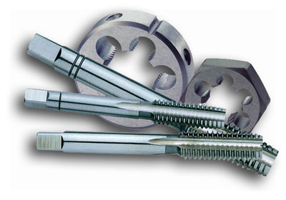](http://www.kmstools.com/blog/wp-content/uploads/2012/01/Taps_and_Dies-Collage.jpg)**

Threads produced using taps and dies, whether by hand or machine, are what is referred to as cut threads. Cut threads are generally of better quality and closer tolerance which is why a die nut run on the threads of a brand-new fastener might still remove some material, and/or plating.

1. **Describe the bench work processes (Thread cutting, Sawing, Chipping, Filling etc)**

**(2015{5},2013{5},2012{8},2009{6.5})**

**Marking**

It is the first and important operation that is performed in bench working, since the accuracy of the product depends upon this. Before marking the surface to be marked is quoted by the chalk paste and allowed to dry. Then the job is kept either on the surface plate or on V block. The measurement is performed on the job by appropriate measuring instrument, then marking is done by scriber, surface gauge and identification is done by punches.

**Chipping**

In this operation, the material is removed in a stock by the help of chisel at room temperature. For large surface, first the metal is removed by cross cut chisel and then remaining metal is chip off by other chisels while chapping lubrication is necessary for better life of chisels. For chipping three things are important 1st proper selection of chisel based on operation, 2nd proper grip of the chisel and appropriate position of standing by the operator. It is very accurate method of removing metal in a more quantity with a reasonable finish.

**Sawing**

It is an operation which is required to cut the metal in different shapes and sizes. It should be done slowly and standing position is appropriate for this operation. Cutting takes place in forward stroke of hacksaw and backward stroke is ideal. During operation, full length of blade should be used. The best result is obtained if the hacksaw blade is fixed I proper direction with correct tension. Coolant must be used while cutting.

**Filling**

It is an operation which is performed by the help of files. The pressure for cutting should be exerted in the forward stroke and backward is ideal. If the file is moved diagonally on the flat surface then it gives the best results. Initially a rough file is used to remove the rough metal followed by a smooth file for better finish. Filling is done by three ways first cross filling is for more metal removal then followed by straight filling and draw filling for final finish.

**Thread Cutting**

**Tapping -**It is an operation of cutting the interval threads by the help of tap and a tap holder manually.

**Dieing-**It is the process of cutting external threads by the help of die and die holder.

1. **Explain the different types of forging (Smithy, Drop forging, Press forging, Machine forging) (2012{4.5},2011{6.5},2010{6.5},2010{5,6},2009{6.5})**

Forging is the operation where the metal is heated and then a force is applied to manipulates the metals in such a way that the required final shape is obtained. Forging is generally a hot working process through cold forging is used sometimes. Type of forging:

**Smith forging -**This is the traditional forging operation done openly or in-openly dies by the village black smith or modern shop floor by manual hammering or by the power hammer. The process involves heating the stock in the black smith hearth and then beating it over the anvil. To get the desire shape the operator must manipulate the component in between the blows. Types of operation available are fullering, flattering, bending, upsetting and swaging.

**Drop Forging-** This is the operation done in closed impression dies by means drop hammer here the force for shaping the component is applied in a series of blows. Drop forging utilizes a closed impression die to obtain the desire shape of the component, the shaping is done by the repeated hammering given to the material in the die cavity. The equipment uses for delivering for blows are called drop hammers. The drop forging die consists of two halves. The lower halve of the die is fixed to the anvil of the machine, while the upper halve is fixed to ram. The heated stock is kept in the lower die, while the ram delivers 4-5 blows on the metal spreads and completely fills in the die cavity. When the two die of halves closed the complete is formed. The typical products obtained in drop forging are cranks, crank shaft, connecting rods, wrench, crane hooks etc.

**Press Forging-** Similar to the drop forging, the press forging is also done in closed impression dies with the expectation that the force is continuous squeezing type applied by the hydraulic press. Press forging dies are similar to drop forging dies as also the process in press forging, the metal is shaped not by means of a series of blows as in drop forging , but by means of a single continuous squeezing action. This squeezing is obtained by means of hydraulic presses. Because of the continuous action of by hydraulic presses, the material gets uniformly deform throughout its entire depth, the press forging dies with the various impression, such as fuller, bender and finisher impression properly arranged.

**Machine Forging-** Unlike the press or drop forging where the material is drawn out, in machine forging the material is only upset to get the desire shape. As it involves the upsetting operation some time it is simply called as upset forging. Because of the beneficial grain flow obtain from upsetting. The die set consists of die and corresponding punch or a heading tool. The die consists of two parts, one called the stationary gripper die which is fixed to the machine frame and the other movable gripper die which moves along with the die slide of the up setter. The stock is held then between these two gripper dies. The upset forging cycle start with the, movable die sliding against the stationary die to grip the stock. The two dies when in closed position from the necessary die cavity then the heading tool advance against the stock and upset it to filled to the die cavity. Like drop forging it is not possible to get the final shape in a single pass in machine forging also. Therefore, the operation is carried out in number of stages. The die cavities is required for the various operations are all arrange vertically on the gripper dies. The stock is the move from stage one to another in proper sequence till the final forging is ready.

1. **Explain the types of forging. (2014{5},2012{8},2011{6})**

**Cold Forging**

Forging is carried out at or near room temperature (below the recrystallization temp.) of the metal. Carbon and standard alloy steels are most commonly cold forged. Cold forging is generally preferred when the metal is already a soft, like aluminium. This process is usually less expensive than hot forging and the product requires little or no finishing work. Cold forging is also less susceptible to contamination problems, and the final component features a better overall surface finish.

**Warm Forging**

The temperature range for the warm forging of steel runs from above room temperature to below the recrystallization temperature. Compared with cold forging, warm forging has the potential advantages of: Reduced tooling loads, reduced press loads, increased steel ductility, elimination of need to anneal prior to forging, and favourable as-forged properties that can eliminate heat treatment. In warm forging, the billet is heated below the recrystallization temperature, up to 700 to 800 0C for steels, to lower the flow stress and the forging pressures.

**Hot Forging**

Forging is carried out at a temperature above the recrystallization temperature of the metal. The recrystallization temperature is defined as the temperature at which the new grains are formed in the metal. This kind of extreme heat is necessary in avoiding strain hardening of the metal during deformation.

1. **What are the advantages and disadvantages of hot working? (2012{5,6.5},2011{4.5})**

**Advantages:**

* Porosity of the metal is minimized.
* In hot working, large deformation can be obtained.
* In hot working process, the grain structure of the metal is refined and thus mechanical properties are improved.
* If the process is carried out properly it doesn’t affect tensile strength, hardness, corrosion resistance etc.
* If there are any concentrated impurities in the metal, they are disintegrated and distributed throughout the metal.
* No residual stresses are introduced in the metal due to hot working.

**Disadvantages:**

* Handling and maintaining of hot working setups is difficult and troublesome.
* Because of the thermal expansion of metals, the dimensional accuracy in hot working is difficult to achieve.
* As the name is hot working so rapid oxidation occurs.
* Friction and tool wear are more severe in hot working.
* All metals cannot be hot worked because of their brittleness at high temperatures.

1. **Name some hot working processes. (2015{5},2014{6},2012{6.5})**

**Forging:** Forging is the operation where the metal is heated and then a force is applied to manipulates the metals in such a way that the required final shape is obtained. Forging is generally a hot working process through cold forging is used sometimes.

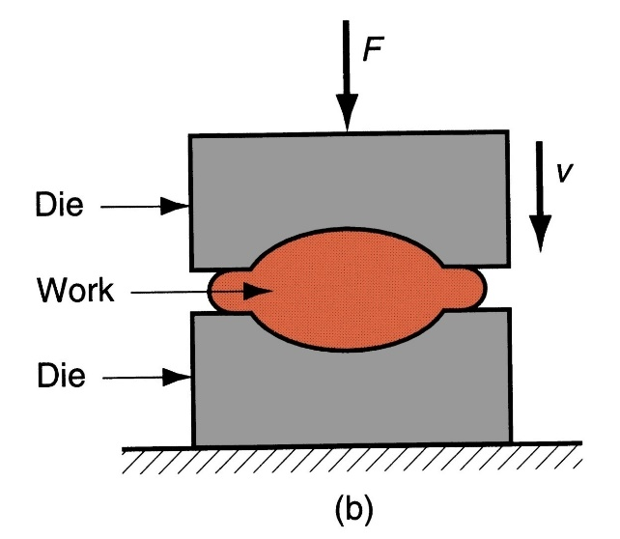

**Rolling:** Rolling is a process where the metal is compressed between two rotating rolls for reducing its cross-sectional area. This is one of the most widely use of all the metal working processes. Because of its higher productivity and low cost. Rolling would be able to produce components having cross sectional throughout its length. May shape such as it and channel section are possible, but not very complex shapes. The metal is taken into rolls by friction and subsequently compressed to obtain the final shape. The thickness of the metal that can down into rolls depends on the roughness of the roll surface. Rougher rolls would be able to achieve greater reduction than smoother rolls.

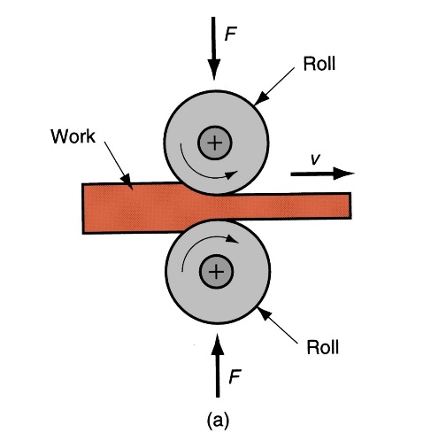

**Extrusion:** Extrusion is the process of confining the metal in a close cavity and then allowing it to flow from only one opening, so that the metal will take the shape of the opening. The operation is identical to the squeezing of toothpaste out of the toothpaste tube. By the extrusion process, it is possible to make component which have a constant cross section over any length as can be formed by the rolling process. Complexity of parts that can be obtain by extrusion is more than that of rolling, because the die required being very simple and easier to make. Also, extrusion is a single pass process, unlike rolling the amount of reduction that is possible in extrusion is large. Generally brittle materials can be very easily extruded.

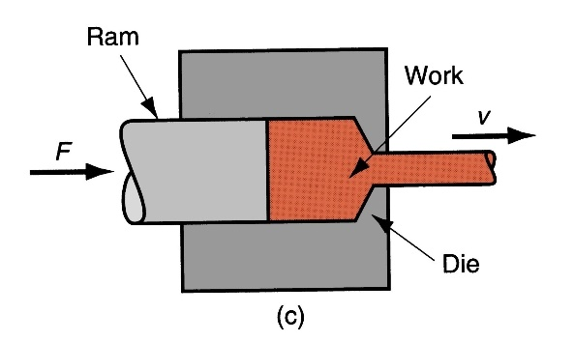

**Hot Drawing:** The drawing metal forming is mostly used to manufacturing of wire from the round bars, except instead of pressure from back end. The wire is pulled from front side where it is emerging from circular die. It is effective method for producing the wire, based on cross sectional die required. Thus, dies are made from hardened tool steels or tungsten carbine materials. Drawing and extrusion are may be hot (stock heated with high temperature) or cold (stock not heated).

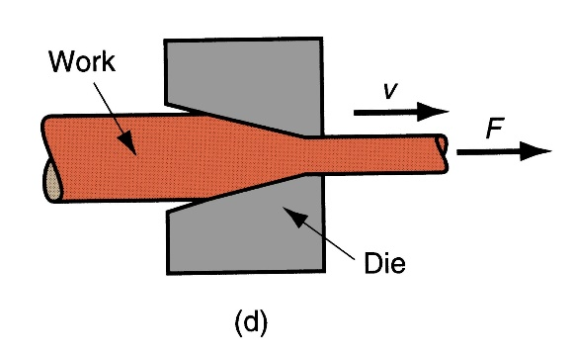

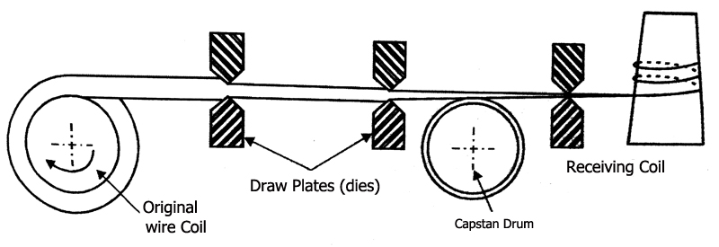

**Unit 1**

1. **What are the different types of casting defects.**

**Misrun**

When the molten metal fails to fill the casting cavity or when the molten metal has solidified before filling mold cavity completely.

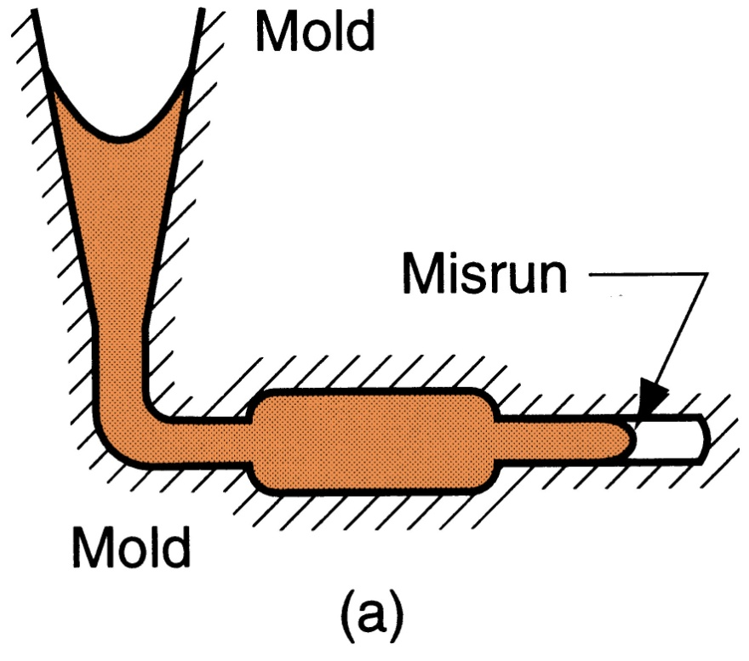

**Causes:**

* Slow pouring time of molten metal
* Rate of metal solidification is faster

**Remedies:**

* Metal should be poured in a faster or intermediate way
* Metal should be at a very high temperature

**Cold Shut**

When two streams of molten metal approach each other in mound cavity from opposite sides and fail to fuse properly or when two portions of metal flow together and there is lack of fusion due to freezing.

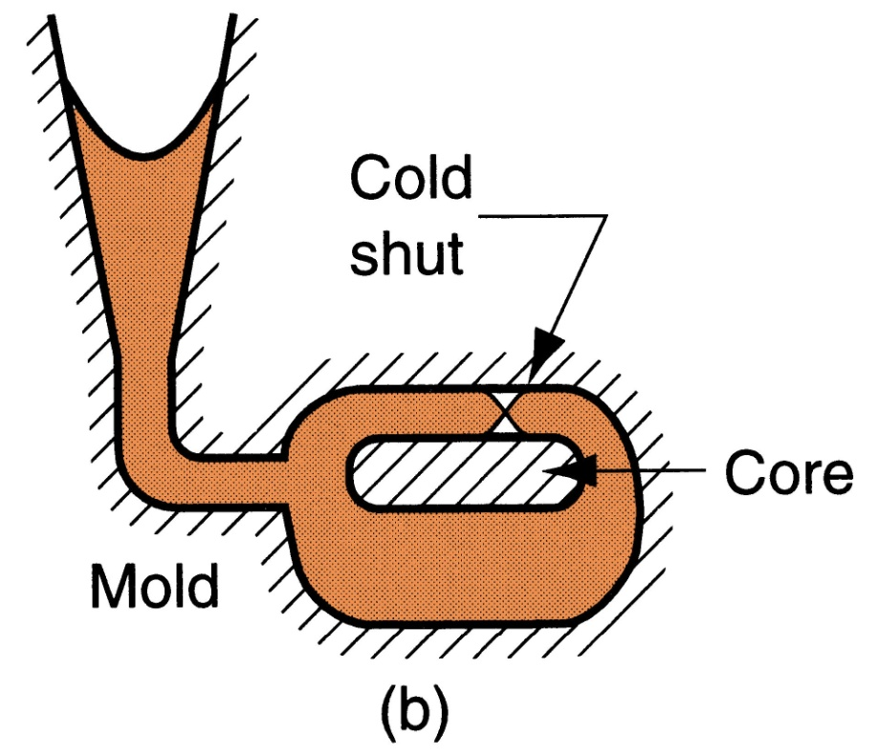

**Causes:**

* Low temperature of molten metal
* Too thin casting section
* Slow pouring time of molten metal
* Use of damaged pattern

**Remedies:**

* Metal should be at a very high temperature
* Casting sections should be appropriate
* Metal should be poured in a faster or intermediate way
* Use of damaged pattern should be avoided

**Cold Shot**

It is caused when metal splatters during pouring and solid globules form that entrapped in casting.

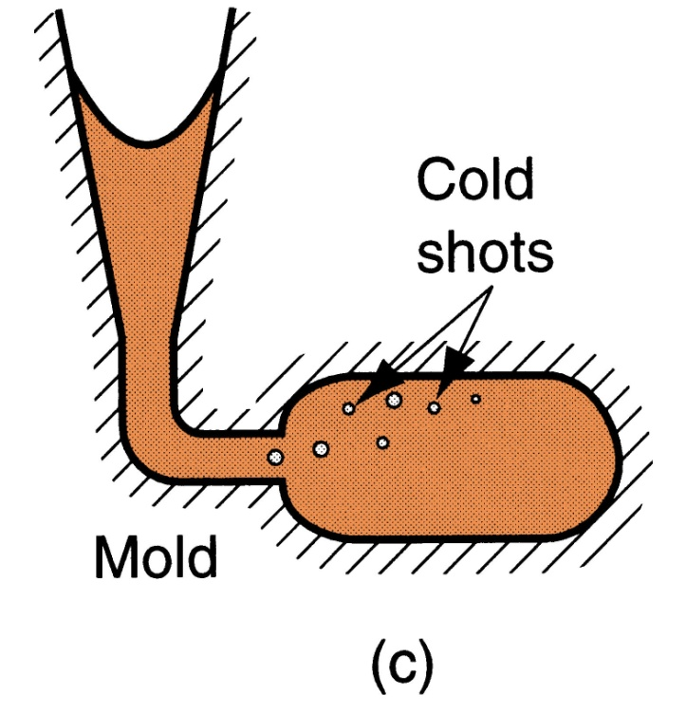

**Causes:**

* When molten metal is poured from a height
* When molten metal is poured very fast
* Faster solidification of molten metal

**Remedies:**

* Molten metal shouldn’t be poured from a higher level
* Metal pouring should be in an intermediate manner
* Metal pouring temperature should be accurate
* Use of damaged pattern should be avoided

**Shrinkage Cavity**

It is a void on the surface of casting caused by uncontrolled solidification of metal or the depression in surface that restricts amount of molten metal available in last region to freeze.

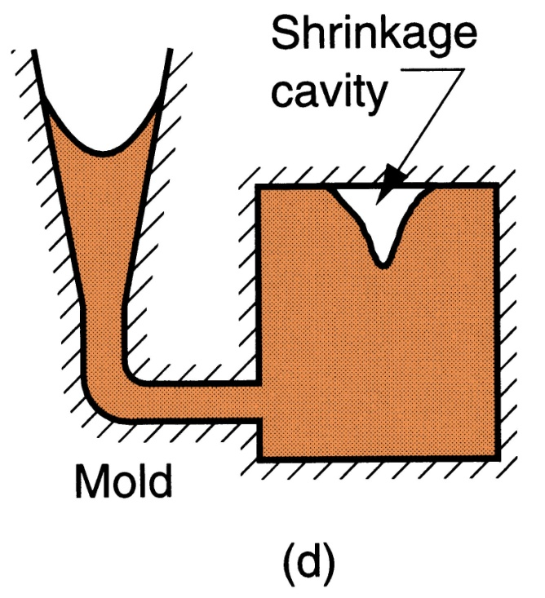

**Causes:**

* Inadequate or improper grading
* Too high pouring temperature
* Poor design of casting

**Remedies:**

* Proper grading of sand should be done while making the cast
* Metal should be poured at the appropriate temperature
* Casting sections shouldn’t be too intricate

**Blowholes**

A balloon‑shaped gas cavity is formed on the surface of casting because of hot air.

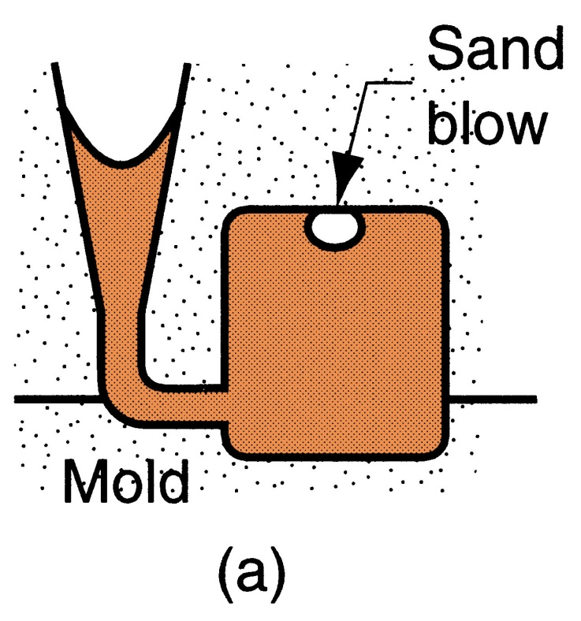

**Causes:**

* Insufficient permeability (property of sand allowing gases to escape) in sand
* Not enough venting in the mold
* Sand may be containing gas producing particles

**Remedies:**

* Sand with more permeability be used
* Proper venting should be done
* Hard ramming should be avoided as it increases permeability

**Pinholes**

A balloon‑shaped gas cavity is formed below the surface of casting because of hot air.

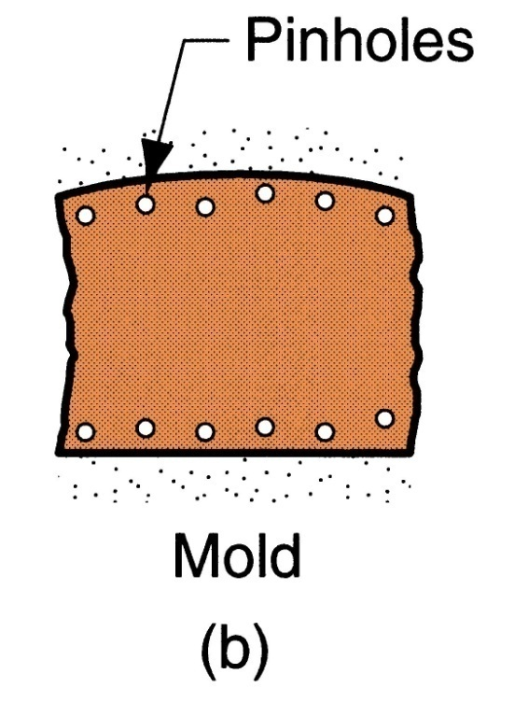

**Causes:**

* Insufficient permeability (property of sand allowing gases to escape) in sand
* Not enough venting in the mold
* Sand may be containing gas producing particles
* Sand with high moisture

**Remedies:**

* Sand with more permeability be used
* Proper venting should be done
* Hard ramming should be avoided as it increases permeability

**Mismatch**

When two parts of the casting are aligned differently at the parting line caused by sidewise relative displacement of cope and drag.

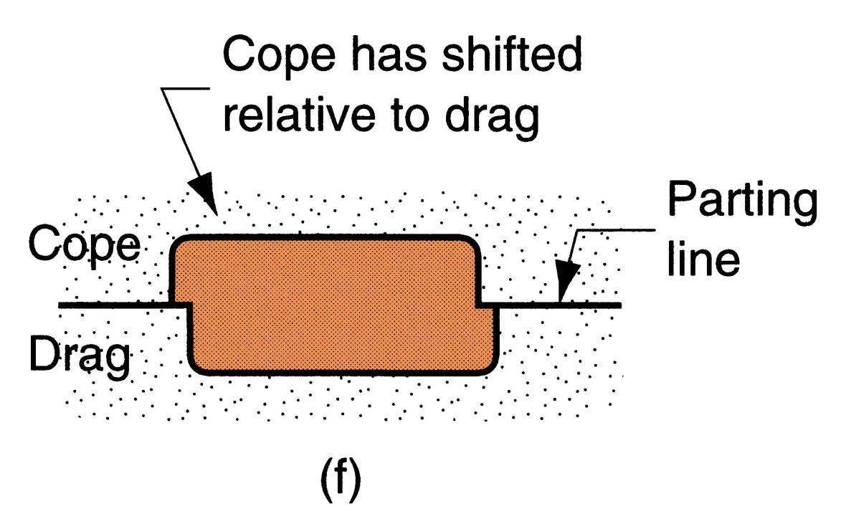

**Causes:**

* Hard ramming of sand
* Usage of worn out dobble pins
* Misalignment of molding bores
* Sand with low cohesiveness or strength.

**Remedies:**

* Hard ramming should be avoided as it increases permeability
* Casting equipments should be checked
* Sand with high cohesiveness be used.

**Penetration**

When fluidity of liquid metal is high, it may penetrate sand mold or sand core making sand a mixture of sand grains and metal.

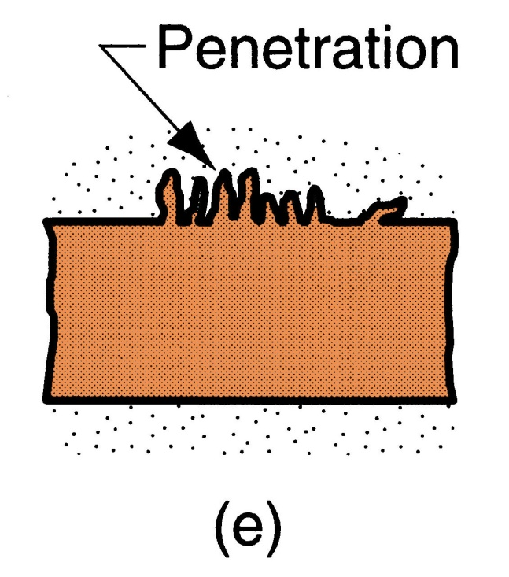

**Causes:**

* Poor ramming of sand
* Large size of molding sand
* Sand with low cohesiveness or strength.

**Remedies:**

* Proper ramming should be done
* Sand should not be containing large particles
* Sand with high cohesiveness be used.

1. **What are the different types of pattern.**

**Solid Pattern**A pattern that is made without joints, parting or any loose pieces - called a single piece or solid pattern. It is not made except for limited production like large and small size castings of simple casts.

**Split Pattern**

A pattern that is most widely used for intricate castings where the depth of the casting is too high then the pattern is split into two parts. The two halves of the pattern should be aligned by making use of the dowel pins.

**Loose piece Pattern**

A pattern used when wwithdrawal of pattern from mould is not possible. Casts have projections, undercuts etc. The obstructing part of the contour is held as loose piece by a wire. After the moulding the main part is removed and the loose pieces are recovered through the gap.

**Match plate Pattern**

A patter where the cope and drag halves along with the gating system and riser are mounted on a match plate on either side. When it is removed after molding, a complete mold with gating system is obtained. It is used for rapid production of small and accurate casting.

**Gated Pattern**

A pattern where production small sized cavities in one mold is required. The gating and runner system are integral part of the gated pattern. A single runner is used for feeding considerable amount of the molding time is saved.

**Removable or Disposable Pattern**

A pattern used for producing multiple identical molds. The pattern is left in the mold instead of being removed from sand. The pattern material vaporizes when the molten metal is poured. So, cavity is created and is filled with molten metal. The method is also known as full mold process or cavity less method.

**Skelton Pattern**

A pattern used where the cast is very large and a skeleton frame is used to combat its huge size. The skeleton frame is generally made of wooden frame and a strike of bar is used for shaping the pattern.

1. **Describe in detail about Investment casting and pattern.**

A pattern made of wax is coated with a refractory material to make mold, after which wax is melted away prior to pouring molten metal. It is a precision casting process capable of castings of high accuracy and intricate detail. Investment casting is also referred to as "lost-wax casting" because the wax pattern is melted out of the mould after it has been formed. Lox-wax processes are one-to-one (one pattern creates one part), which increases production time and costs relative to other casting processes. However, since the mould is destroyed during the process, parts with complex geometries and intricate details can be created. Investment casting can make use of most metals, most commonly using aluminium alloys, bronze alloys, magnesium alloys, cast iron, stainless steel, and tool steel. This process is beneficial for casting metals with high melting temperatures that cannot be moulded in plaster or metal. Parts that are typically made by investment casting include those with complex geometry such as turbine blades or firearm components. High temperature applications are also common, which includes parts for the automotive, aircraft, and military industries.

Step 1 &2

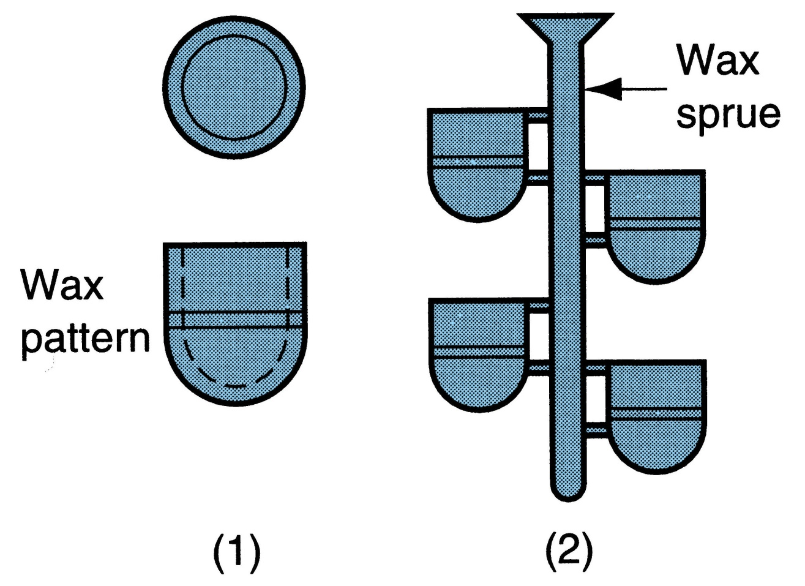

1. Wax patterns are produced
2. Several patterns are attached to a sprue to form a pattern tree.

Step 3 & 4

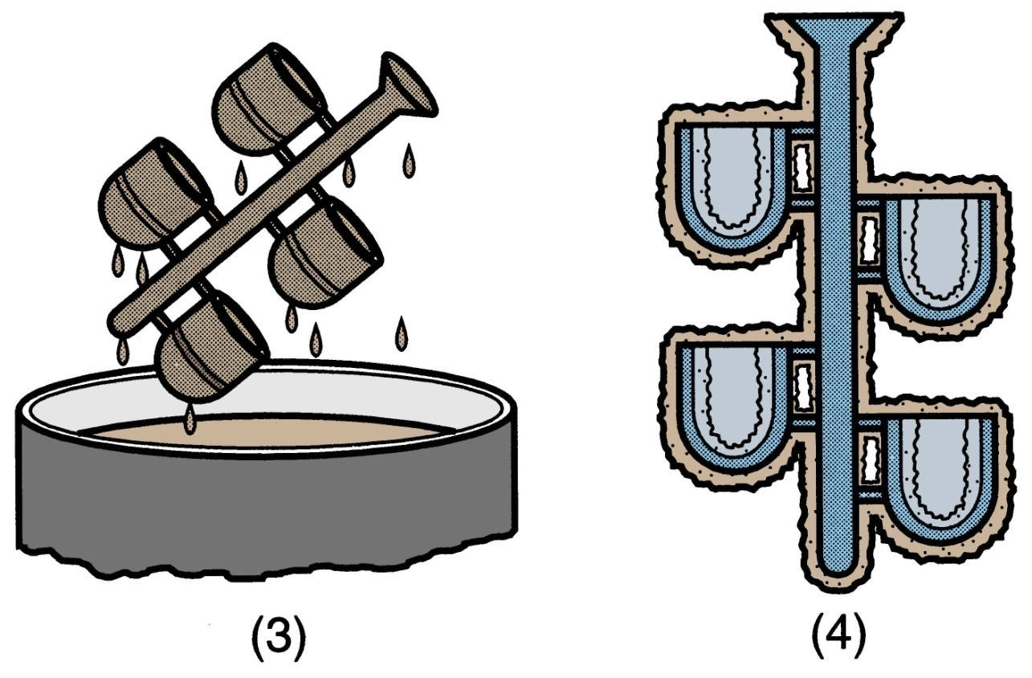

1. The pattern tree is coated with a thin layer of refractory material
2. The full mold is formed by covering the coated tree with sufficient refractory material to make it rigid

Step 5

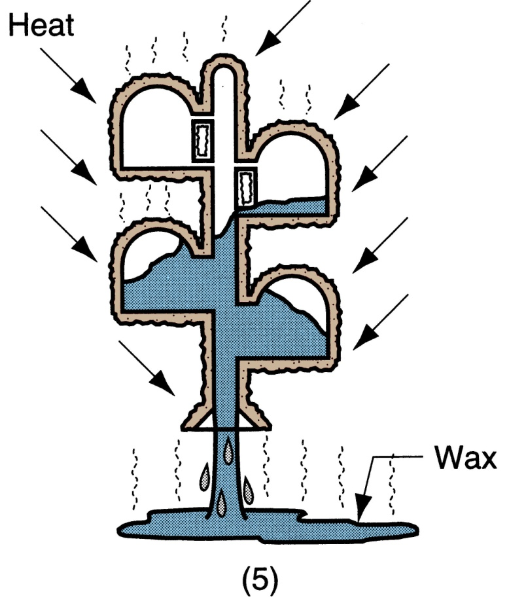

1. The mold is then held in an inverted position and heated to melt the wax and allow it to drip out of the cavity.

Step 6

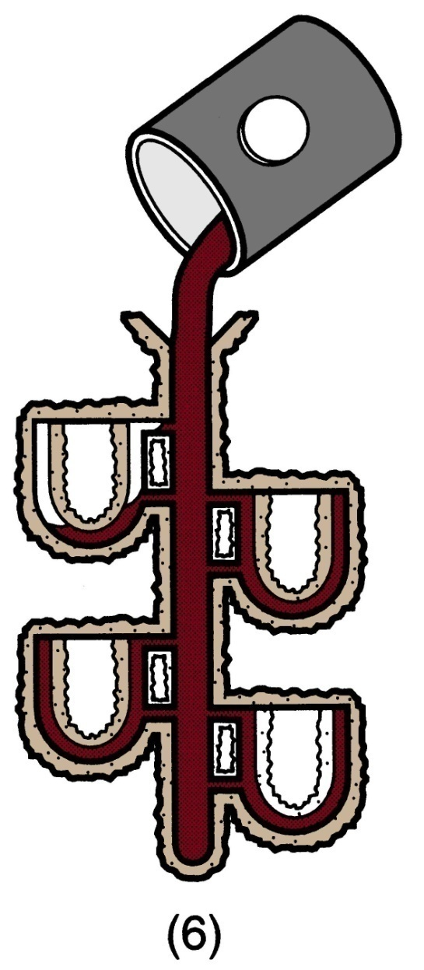

1. Then the mould is preheated to a high temperature, which ensures that all contaminants are eliminated from the mould and allows the liquid metal to flow more easily into the detailed cavity and the molten metal is poured for solidification.

Step 7

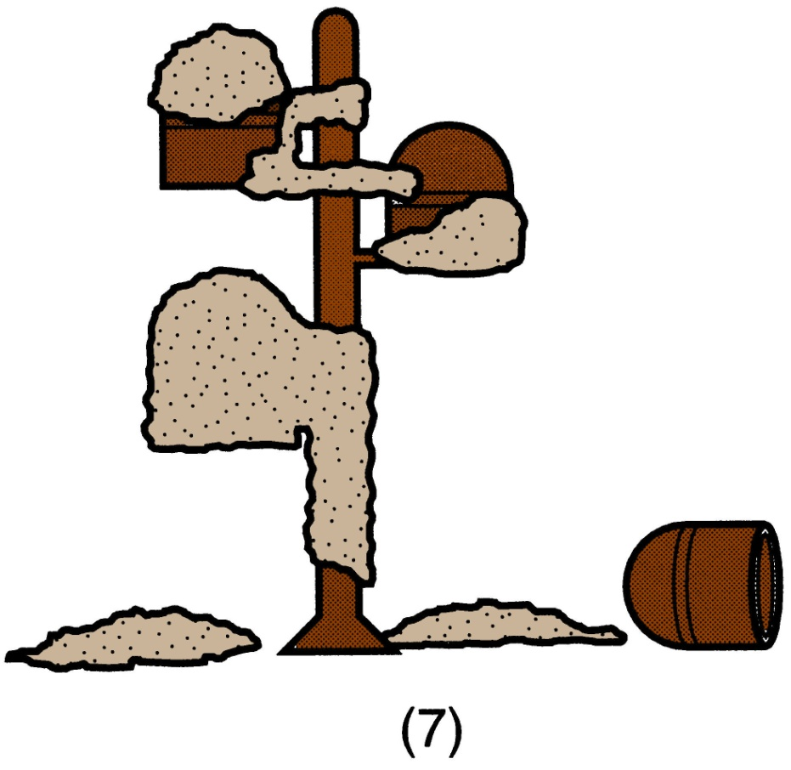

1. The mold is broken away from the finished casting and then parts are separated from the sprue.

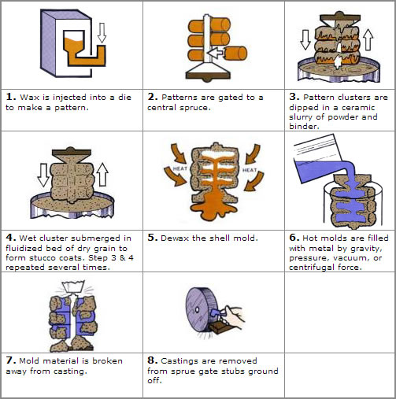

1. What is normalising & case hardening? Explain with properties.
2. Explain the composition & properties of Bronze & Duralium
3. Explain the characteristics of good sand.
4. Explain the cupola furnace with reactions.
5. Explain the gating system & different types of gates.
6. Explain different types centrifugal casting.
7. Explain the different heat processes.
8. Explain die casting & the processes involved.